Water Quality Indicators Guided Notes
Parts Per Million
- Most __________________ substances found in ______________ are measured in parts per million (____________) or even smaller amounts.
- This means that for every ______ million parts (units) of water there is a certain number of parts of the ______________________.
- Example: 8 / 1,000,000 = _______ ppm

Water Quality Indictors
- Alkalinity
  - is _________________________________ to neutralize _____________.
  - produced by minerals such as __________________________________.
  - _________________ sediment composed of __________________________________________.
  - Water with ______________ alkalinity is usually _________________________.

- Ammonia
  - produced by the ________________ of organic matter and animal ___________________.
  - ___________________________ to most aquatic life, especially at high ________.
  - Bacteria readily ____________________ ammonia to _______________________.
  - Nitrates are a plant _______________________________
  - is a form of ___________________ and part of the ____________________________________.

- Bacteria
  - Most bacteria are ___________________ in nutrient and other organic cycles.
  - Excess ______________________ cause algal ___________________.
  - As algae die and _______________, the high bacterial load rapidly __________________ dissolved oxygen.
  - Certain types of bacteria indicate ____________ and ____________ waste _____________.
  - Escherichia coli are _________________________ bacteria found in the ____________________ of warm-blooded organisms. Most strains are harmless but one E. coli strain can cause severe diarrhea and kidney _______________________.

- Dissolved Oxygen
  - a product of _________________________________ and _____________________________.
  - The ____________________ the water, the _________________ oxygen it can hold.
  - Summer is often a time of oxygen ________________ for _________________ organisms.
  - Most organisms need at least _____ or ____ ppm of oxygen in order to ___________.
  - Even _____________ water rarely contains more than ________ ppm.

- Conductivity
  - measures the water’s ability to __________________________________________________.
  - ___________________ water is a _________________ conductor.
  - The addition of ______________________ solids, especially _______________, increases the __________________________ of water.
  - __________________________________ is measured using a conductivity _______________.

- Hardness
  - refers to the _______________ of ______________ and __________________________ in water.
  - Hard water has _______________ concentrations of these _________________.
  - Soft water has ______________ concentrations.
  - Water hardness often originates from _______________________.

- Nitrate
  - a primary plant ______________________.
  - Nitrate is __________ soluble and moves _________ from surface to __________________.
  - Excess nitrate causes _______________ blooms that __________________ water quality.
  - Under normal conditions, the ________________________________ keeps the amount of available nitrogen in _____________________ with the demands.
  - However, excessive use of ________________________ and ___________________________________ release have created a surplus of nitrate.
  - The result is ____________________________________ from excess __________________ and ______________________ with reduced ____________________________________.

- Pesticides
  - Effects on _________________ organisms – Moderately to highly ___________________ to mammals, __________________________, __________________________________, ___________________________ and _______________.

- pH
  - pH is the ____________________ of the ____________________ ion (H+) concentration.
  - The pH scale is ___________ to ___________.
  - Seven is ________, below seven is ________, and above seven is _______ (or _________).
  - Most _________________ organisms exist within a pH range of _________________.

- Phosphate
  - Phosphate’s concentrations in __________ water is generally __________; however, phosphorus is used extensively in _____________ and other _______________.
  - The primary sources of phosphates to surface water are _____________________, _____________________________, and ____________________________________.
  - High levels of _____________________________ can over stimulate the growth of ________________________________ and __________________________.
  - This in turn, will cause high DO ___________________________ and ___________________ to fish and many aquatic ______________________________.

- Sediment
  - ________________________ causes loose soil to ___________________ the waterways
  - Suspended sediment __________________________________ to plants and _____________________________ dissolved oxygen.
  - As sediments settle, they can _____________ bottom (________________) organisms.

- Temperature
  - Most aquatic organisms live within a temperature range of +32º F (+0º C) to 90º F (32º C).
  - Rapid temperature change and temperature extremes can stress aquatic organisms.
  - Temperature affects the oxygen-carrying capacity of water. 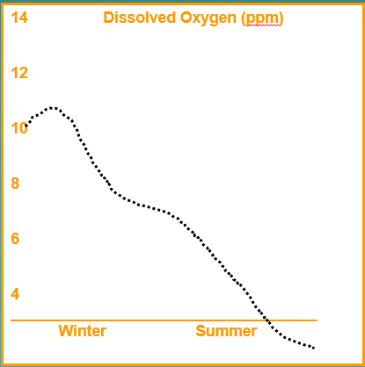
As the water ____________________, the amount of dissolved oxygen ________________________.

- Total Dissolved Solids (TDS)
  - TDS is the measure of the material ______________________ in ______________________.
  - This measure is related to ____________________, _________________ and conductivity.
  - Hard water has _______________ TDS than ______________ water.

- Total Suspended Solids
  - TSS is the measure of the ______________ _________________________ in the water.
  - TSS is related to _________________________.
  - Water with high TSS usually has high __________________________ (TDS) as well.

- Turbidity
  - Turbidity refers to water ________________________.
  - _____________________________ suspended in the water _____________________ turbidity.
  - A __________________________ is one type of instrument used to measure turbidity.

- Toxic Chemicals
  - Toxic chemicals usually come from ________________________ and ________________________ production.
  - The effects are often _____________________ until years after they have entered the _________________________.
  - Toxic chemicals include heavy metals (___________________, mercury), organic compounds (_______________, PCB), inorganic substances (arsenic) and others.

