**Testing for Functions**

In this lesson you will

● represent relationships with tables, graphs, and equations

● use the **vertical line test** to determine whether a relationship is a function

You have written and used many rules that transform one number into another. For example, one simple rule is “Multiply each number by 2.”You can represent this rule with a table, an equation, a graph, or a diagram.

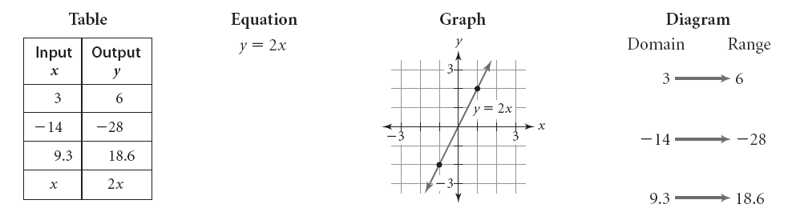

In this lesson you will learn a method for determining whether a rule is a function either by applying the definition of function to graphs and tables.

**Vocabulary**:

Relation:

Function:

Domain:

Range:

**Investigation: Testing for Functions**

In this investigation we will look at different representations of relationships - tables, algebraic statements (equations or inequalities), and graphs. In each case, we will decide whether the relationship represented is a function or not.

**Part I: Tables**

|  |  |
| --- | --- |
| **Table 1** | |
| ***x*** | ***y*** |
| 1 | -2 |
| 2 | 1 |
| 4 | 7 |
| 7 | 16 |
| 10 | 25 |

|  |  |
| --- | --- |
| **Table 2** | |
| ***x*** | ***y*** |
| 1 | -1 |
| 1 | 1 |
| 4 | 2 |
| 4 | -2 |
| 9 | 3 |

|  |  |
| --- | --- |
| **Table 3** | |
| ***x*** | ***y*** |
| -2 | 4 |
| -1 | 1 |
| 0 | 0 |
| 1 | 1 |
| 2 | 4 |

|  |  |
| --- | --- |
| **Table 4** | |
| ***x*** | ***y*** |
| 2 | -4 |
| 1 | -1 |
| 0 | 0 |
| 1 | 1 |
| 2 | 4 |

Look at Table 1. Each input has only one output, so the relationship is a function.

In Table 2, the input values 1 and 4 each have two different possible outputs: the *x*-value 1 has corresponding *y*-values of -1 and 1, and the *x*-value 4 has corresponding *y*-values of 2 and -2. So Table 2 does not represent a function.

Table 3 represents a function and Table 4 does not. Explain why for each table.

**Part II: Equations**

|  |  |  |  |
| --- | --- | --- | --- |
| **Statement 1** | **Statement 2** | **Statement 3** | **Statement 4** |
| $$y=2x+1$$ | $$y=\sqrt{x}$$ | $$y=x^{2}$$ | $$y<-2x+4$$ |

Consider Statement 1, $y=2x+1$. For any *x*-value that you input, you multiply by 2 and then add 1. There is only one possible output value that can result for any given input value. So Statement 1 represents a function.

For Statement 2, can you think of two different *y*-values that correspond to a single *x*-value? If $x=4$, *y* can be 2 or -2, so Statement 2 does not represent a function.

Statement 3 represents a function, and Statement 4 does not. Explain why for each statement.

**Part III: Graphs**

**Graph 1 Graph 2 Graph 3 Graph 4**

*y*

*x*



You can move a vertical line, such as the edge of a ruler, from left to right on a graph to determine whether the graph represents a function. If the vertical line ever intersects the graph in more than one point, you know that there is an *x*-value that has more than one corresponding *y*-value, so the graph is not a function.

Graph 1 represents a function because no vertical line will intersect the graph more than once.

For Graph 2, however, 3 of the 4 vertical lines pictured intersect the graph twice. For each of these three *x*-values, there are two corresponding *y*-values, one positive and one negative, so the graph is not a function.



What about Graphs 3 and 4? For each graph, determine whether it is a function or not and explain why.

The **vertical line test** helps you determine whether a relationship is a function by looking at its graph. If all possible vertical lines cross the graph only once or not at all, then the graph is a function. If even one vertical line crosses the graph more than once, the graph is not a function.

***EXAMPLE*** Use the vertical line test to determine which relationships are functions.

*y*

*x*

*y*

*x*

*y*

*x*

*y*

*x*

*y*

*x*

***EXAMPLE*** Does each relationship of the form (input, output) represent a function? If the relationship does not represent a function, find an example of one input that has two or more outputs.

1. (city, zip code)
2. (person, birth date)
3. (last name, first name)
4. (state, capital)

Give an example of an (input, output) relationship that is a function.

Give an example of an (input, output) relationship that is not a function.

***EXAMPLE*** Determine whether each table of *x*- and *y*-values represents a function. Explain your reasoning.

|  |  |
| --- | --- |
| **Input**  ***x*** | **Output**  ***y*** |
| 0 | 5 |
| 1 | 7 |
| 3 | 10 |
| 7 | 9 |
| 5 | 7 |
| 4 | 5 |
| 3 | 8 |

|  |  |
| --- | --- |
| **Input**  ***x*** | **Output**  ***y*** |
| 3 | 7 |
| 4 | 9 |
| 8 | 4 |
| 5 | 5 |
| 9 | 3 |
| 11 | 9 |
| 7 | 6 |

|  |  |
| --- | --- |
| **Input**  ***x*** | **Output**  ***y*** |
| 2 | 8 |
| 3 | 11 |
| 5 | 12 |
| 7 | 3 |
| 9 | 5 |
| 8 | 7 |
| 4 | 11 |