Scatter Plot, Correlation, and Line of Best Fit Review

1. A baseball coach graphs some data and finds the line of best fit. The equation for the line of best fit is y = 0.32x – 20.51, where x is the number of times at bat and y is the number of hits.

How many hits should he expect from a player who is at bat 175 times?

- 35 hits
Average  Temp (C) | 1.5 | 5.8 | 2.4 | 4.0 | 4.7 | 5.4 | 3.2 | 5.0
Date in  April trees bloom | 28 | 3 | 25 | 21 | 14 | 8 | 20 | 6
- 49 hits
- 609 hits
- 62 hits

2. Below is the table of data regarding the cherry blossom trees in Washington D.C.
A) Make a scatter plot of the given data.

B) Correlation: __________________________
Scatter Plot, Correlation, and Line of Best Fit Review

3. At the Happy Paper company the more boxes of paper you order the cheaper the price you have to pay for each box of paper. Below are the prices charged per box of paper to different companies ordering various quantities of paper.

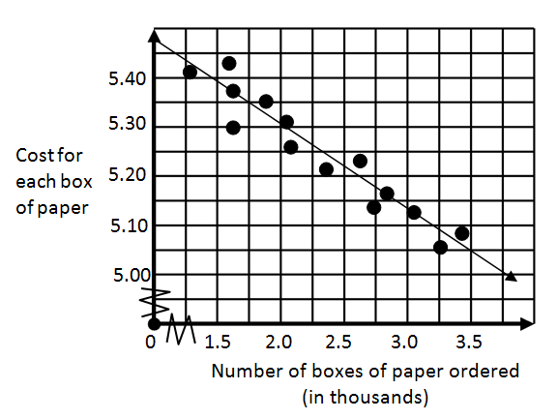

Using the line of best fit, if your company wants to only pay $5.05 for each box of paper, how many boxes of paper should be ordered from Happy Paper company?

4. Determine the correlation for each statement.

- The number of people at your party and the number of sodas you have in the refrigerator.

- The amount your drive to school and the amount you have to pay for gas.

- The size your dog and the number of times you take it to the vet.

