Evolution of Landforms Test

WEGENER, CONTINENTAL DRIFT, & LAW OF SUPERPOSITION
- A mass extinction is when many different species die out (go extinct) at the same time.
- Alfred Wegener developed the theory of continental drift.
- Many scientists reject the initial continental drift hypothesis because there was not an explanation of how the continents moved.
- The best evidence that two continents were once connected is that they have similar rocks and fossils.
- The Law of Superposition helps scientists to determine the age of layers of rock.

GEOLOGIC TIME SCALE
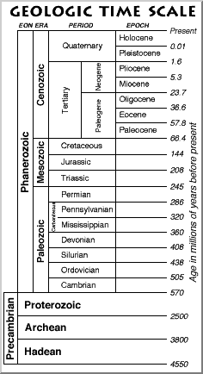
- An eon is the largest unit of geologic time.
- An epoch is the smallest unit of geologic time.
- Extinction is the most likely outcome for a species if the environment changes more quickly than the species can adapt.
- Mass extinctions are mainly used to subdivide geologic time into different units or periods.
- Precambrian time makes up most of Earth’s history in millions of years.
- We live in the Phanerozoic Eon, Cenozoic Era, and Quaternary period.

FOSSILS
- Fossils are found in sedimentary rock. Substances like mud and sand create good fossils.
- Hard substances, like bones, are most likely to be preserved as a fossil. Soft tissue is very unlikely to become a fossil.
- Index fossils are geographically widespread and existed for a geologically long period of time.
- There are many different kinds of fossils: casts, molds, preserved, trace, and . . .
- We do not have fossils of all organisms that lived in Earth’s past because heat/pressure from igneous or metamorphic rock can destroy fossils and conditions must be just right for fossils to form.

ROCK LAYERS & FOSSILS
For each diagram, order the rock layers from oldest to youngest. Identify which fossils are oldest.

