Common Core Math 1 Name ___________________
One-Variable Data Date _______________
Homework: Introduction to Statistics

1. Determine whether the following data is categorical (C) or quantitative (Q)

a. The candidate a survey respondent will support in an upcoming election.

b. The number of televisions in a household.

c. The distance kickers for a football team can kick a football.

d. The kind of tree in each person’s front yard in a neighborhood.

e. The type of blood a person has.

2. A math student is interested in figuring out the average price of vehicles at Glentown High School. She takes a sample of 50 cars in the school’s parking lot and finds the average value to be $13, 400.

a. What is the population?

b. What are the elements?

c. What data is being collected? (Include units if applicable)

d. What type of data is it (categorical or quantitative)? How do you know?

3. Describe that data in terms of center, spread, shape, and outliers. State all in terms of the context.
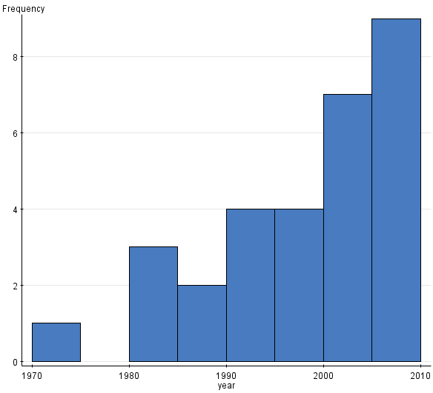
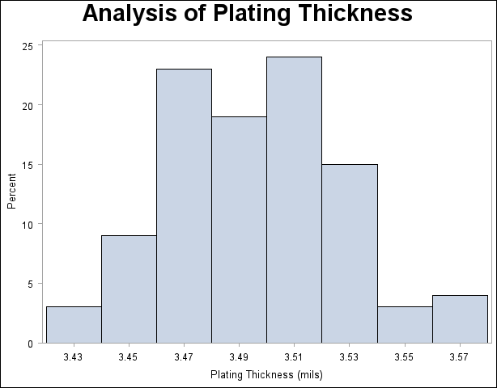
a. b.

Center: Center:
Shape: Shape:
Spread: Spread:
Outliers: Outliers:

