Name ____________________________________________ Period ___________ Date __________________

**Math I Interpolation and Extrapolation Notes**

Define the following:

Interpolate

Extrapolate

Reliability

**12**

**10**

**8**

**6**

**4**

**2**

**Example 1: The following graph shows the cost of a taxi ride (c) as a function of the distance travelled (d).**



a. What is the approximate value when d = 2? __________



Did you interpolate or extrapolate to find this value?

Cost (dollars)

b. What is the approximate value when c = 8? __________

Did you interpolate or extrapolate to find this value?

c. What is the approximate value when d = 8? _________

Did you interpolate or extrapolate to find this value?

**0 2 4 6 8 10 12 14**

Distance Travelled (miles)

d. What is the approximate value when c = 12? ________

Did you interpolate or extrapolate to find this value?

e. Write an explicit and a recursive rule to model the information provided in the graph. Interpret the slope and y-intercept of your explicit rule in the context of the problem.

**Example 2: The table below shows the relationship between the speed (s) of a car and its stopping distance (d).**

|  |  |
| --- | --- |
| **Speed (km/h)** | **Stopping Distance (m)** |
| **15** | 5 |
| **30** | 15 |
| **45** | 25 |
| **60** | 35 |
| **75** | 45 |

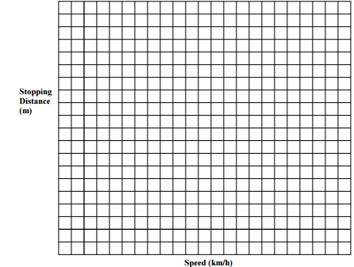 a. Plot the data from the table and draw in a trend line.

b. Make an observation about the relationship between the speed and the stopping distance.

b. What would be the speed of a car with a stopping distance of 55 meters? ______________

Is this interpolation or extrapolation?

c. What would be the stopping distance if the car was traveling 80 km/h? _______________

Is this interpolation or extrapolation?

d. What would be the speed of a car with a stopping distance of 40 meters? _______________

Is this interpolation or extrapolation?

e. What are some factors that would make this model unreliable when determining stopping distance?