Name: _______________________________________
Date of test: _________________

______ Review hydrology vocabulary two times.

Answer the following completely.

- What is the hydrosphere?

- What are these properties of water? Describe and give a real life example of each property.

Cohesion

Adhesion

Capillarity

Surface tension

Specific heat

Density

Universal solvent

Polarity

- Describe the following wetlands:

Bog-

Sound-

Salt marsh-

Estuary
- Draw a river basin that consists of two watersheds and a delta describe how water moves through the river basin.

- If you wanted to decrease your amount of mercury exposure which fish should you try not to eat very much of? Describe how mercury is passed in a food chain.
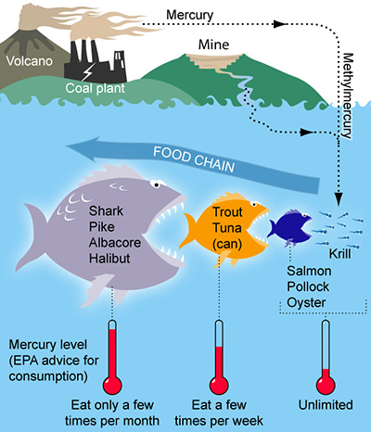

- How do wetlands clean the water?

- Compare the following types of water.
Salt water

Rain water

Ground water

Runoff

- In the drawing use a blue colored pencil to follow the path of water moving through the plant. Then label where the following processes are occurring.
osmosis capillary evaporation
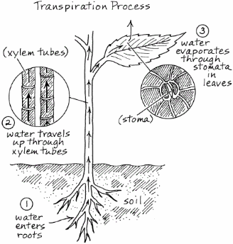

- Compare permeable and impermeable, saturated and unsaturated.

- Classify the following as either permeable or impermeable
Sand
Gravel
Granite
Hard clay
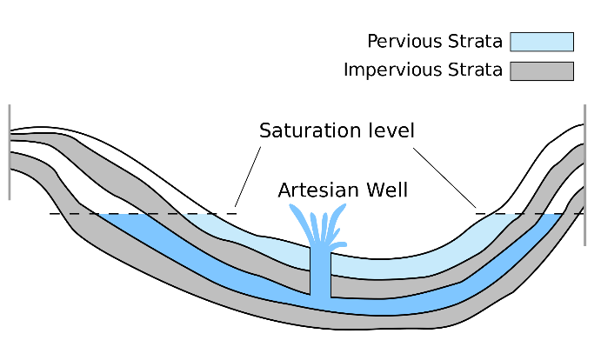
- Describe what causes an artesian well using the diagram above.

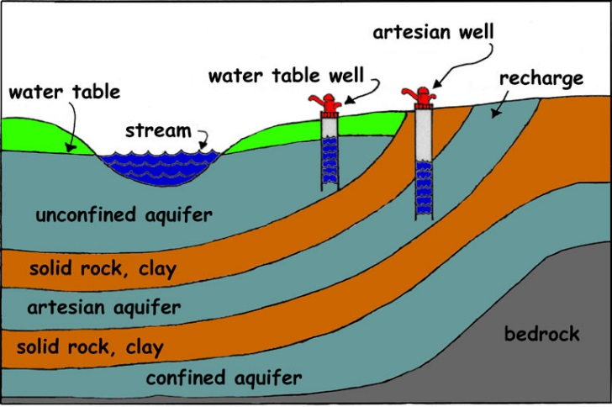
- Using the diagram above, compare the three types of aquifers, unconfined, artesian and confined.

- Describe the following water legislation:

Clean water act of 1972-

Marine act of 1972-

Safe drinking water act 1974-

Oil pollution act of 1990-

- Nitrates and phosphates can pollute water. Identify the sources of these pollutants.

Nitrates-

Phosphates-

- Compare point and non-point pollution in a t-chart

Point | Non-Point

- Define the following terms:
pH

acidic

basic

neutral

- What pollutant is often found in road or parking lot runoff?

- What are these tests of water quality? How do their values effect an ecosystem?
Turbidity
Salinity
pH

- Illustrate the two types of lake turnover. Describe when they occur and the process that causes lakes to turnover. What benefit to the ecosystem is lake turnover?

- As the temperature in a lake increases the dissolved oxygen(DO)_____________. As the temperature in a lake decreases the dissolved oxygen(DO)_______________. Due to this fact summer is a period of __________ _____________ levels.

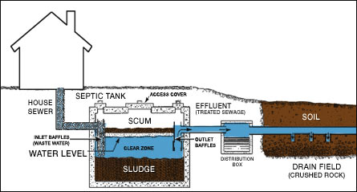
- Illustrate and compare a vegetative riparian buffer and a non-vegetative buffer.

- What causes eutrophication and what is a result of eutrophication?

- Describe the wastewater treatment process. Explain each of the three main steps.

- What is sewage?

- What is the difference between a septic system and waste water treatment facility?

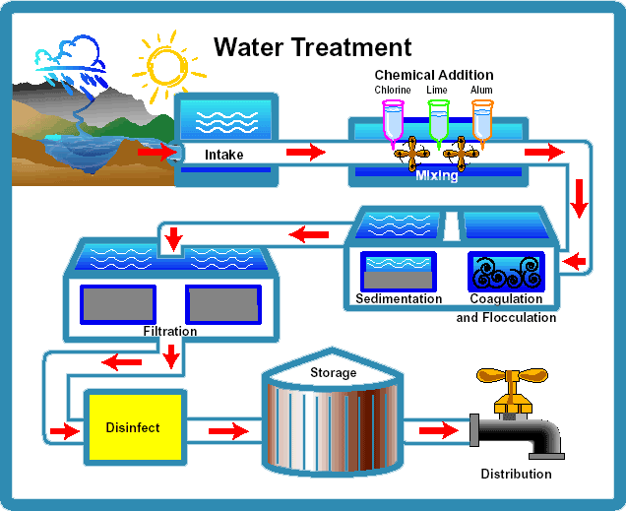
- Describe the treatment given to water from a lake or river before you can drink it?

- What is the density of water? What is the formula we used to calculate density?

- What density does an object need to float in water? _____________

- What density does it need to sink in water? _______________ Why do ice cubes float?

- Why does the concrete surrounding a pool feel hotter than the water in the pool?

- Where is most of the water on Earth? How much is fresh water? How much is available for our use?

- A hog farmer wants to start a new farm next to the reservoir in your town. What concerns would you have about the development of this new farm?

- Look at the macroinvertebrates below? Which species indicate good water quality?
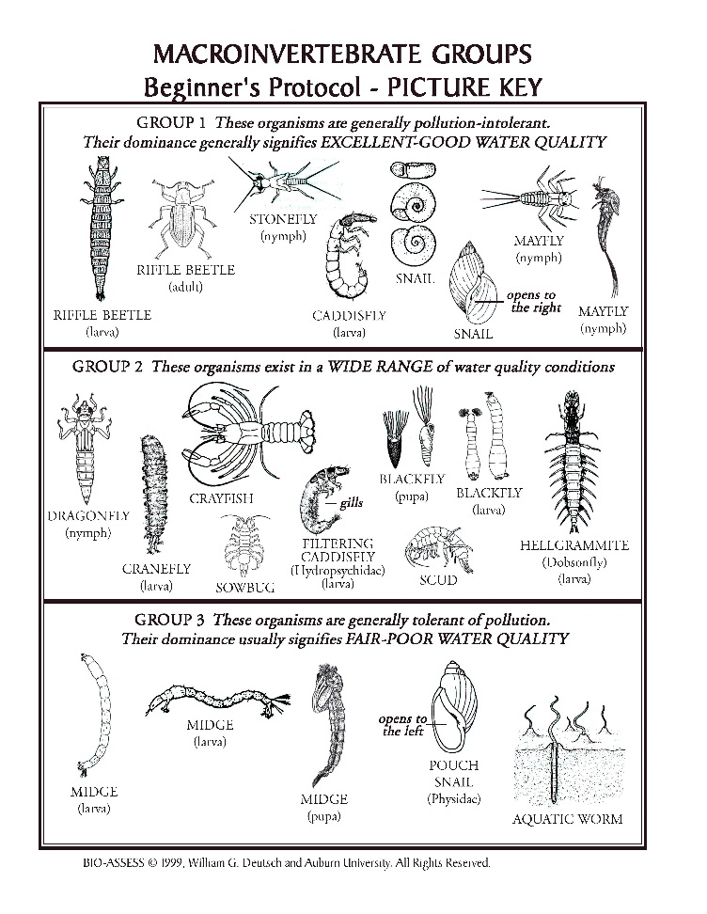
- You see Trout in a stream. What does this bioindicator tell you about this stream?

- What effect do wind and waves have on water quality?

