***Given******the sequence 3, 6, 9, 12, ….***

|  |  |  |
| --- | --- | --- |
| The relationship between the term number and the value can be expressed by **a table**. | The relationship can also be expressed as **a set of ordered pairs**. | Or the relationship can be expressed by **a mapping diagram** |
|  | {(1, 3), (2, 6), (3, 9), (4,12)} |  |

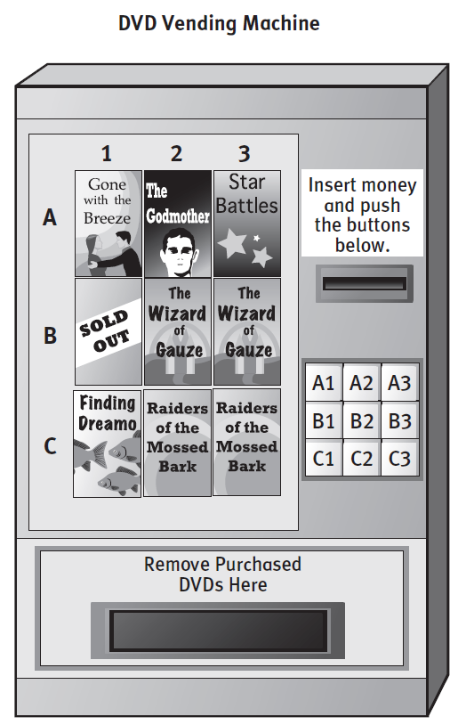

Investigation

1. Make a table showing the relationship between the buttons on the “RedBox” machine and the movies available for rent.

**Buttons** **Movies**

*A1* *Gone with the breeze*

1. Draw a mapping diagram for your table.

List each movie only once in your mapping.

1. Describe your relation as a set of ordered pairs.
2. The following printout shows the vending machine’s usage. Is the machine working properly?   
   Why or why not?

***{ (A1, Gone with the breeze), (A1, The Godmother), (A3, Star Battle), (B2, Wizzard of the Gauze),   
 (C1, Finding Dreamo), (C3, Raiders of the Mossed Bark)}***

1. Make a table and mapping diagram for the printout above. *For mappings, list each button only once.*

**Buttons Movies**

* **Questions #1-3** describe a vending machine that is working properly.   
  The table, mapping and list represent a relation that **is** a function.
* **Questions #4 and #5** describe a vending machine that is not working properly, or not functional.   
  The list, table and mapping diagram represent a relation that is **not** a function.

1. How can you tell if a relation is a function?
2. Which representation is easiest to pick out a function: table, list or mapping?

**Example 1:** *Tell whether each table represents a function. Explain why or why not.*

|  |  |
| --- | --- |
| *x* | *y* |
| 1 | 3 |
| 2 | 6 |
| 3 | 9 |
| 4 | 12 |
| 5 | 15 |

|  |  |
| --- | --- |
| *x* | *y* |
| 1 | 3 |
| 2 | 6 |
| 2 | 9 |
| 4 | 12 |
| 5 | 15 |

1. 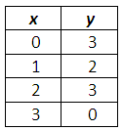

c.

b.

**Domain: ______________ Domain: ______________ Domain: _____________**

**Range: _______________ Range: _______________ Range: ______________**

**Function? (Yes or No): _____ Function? (Yes or No): _____ Function? (Yes or No): _____**

**Example 2:** *Tell whether each mapping diagram represents a function. Explain why or why not.*

1. b. c.

**Domain: ______________ Domain: ______________ Domain: ______________**

**Range: _______________ Range: _______________ Range: _______________**

**Function? (Yes or No): _____ Function? (Yes or No): _____ Function? (Yes or No): _____**

**Example 3:** *Tell whether each set of ordered pairs represents a function. Explain why or why not.*

1. {(–1, 3), (–3, –2), (5, 7), (0, –2)} b. {(0, 3), (3, -1), (4, 8), (0, –2)}

**Domain: ______________ Domain: ______________**

**Range: _______________ Range: _______________**

**Function? (Yes or No): _____ Function? (Yes or No): _____**

**Example 4:** *List the ordered pairs for the points of the each graph.**Is each graph a function?*

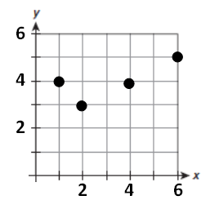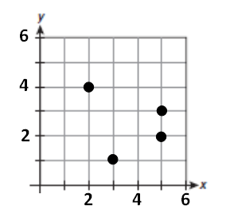

a.

b.

**Ordered Pairs: ______________________________ Ordered Pairs: ____________________________**

**Function? (Yes or No): ______ Function? (Yes or No): ______**

C:\Documents and Settings\mwright4\Local Settings\Temporary Internet Files\Content.IE5\OGL1YODB\MC900410605[1].wmfSome graphs contain too many points to list. To decide if a graph is a function, use the **vertical line test.**

***If a vertical line touches more than one point on the graph, it is not a function.***

**Example 5:** *Use the vertical line test to determine which relationships are functions.*

*y*

*x*

*y*

*x*

*y*

*x*

*y*

*x*

*y*

*x*