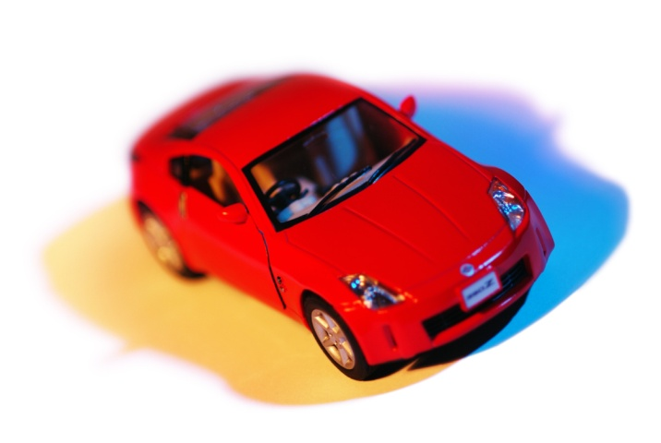
Exponential Decay: Depreciation Problems
Most cars lose value each year by a process known as depreciation. You may have heard before that a new car loses a large part of its value in the first 2 or 3 years and continues to lose its value, but more gradually, over time. That is because the car does not lose the same amount of value each year, it loses approximately the same percentage of its value each year. What kind of model would be useful for calculating the value of a car over time?

Let us look at an example of depreciation: Suppose the value of car when new is $20,000 and it depreciates at a rate of 20% each year. What is the percentage rate of depreciation each year?

The percentage rate of depreciation is 20%, which means that 80% of the value of the car remains every year. We can calculate this percentage rate by subtracting 20% from 100% in order to calculate the value remaining of 80% each year.

What is the initial value of the car? $___________
What is the percentage rate? 100% - 20% = ___% each year. Write that percentage as a decimal. ______

Let us look at the depreciation data over a 5 year period of time (rounded to the nearest dollar).

Number of Years | 0 | 1 | 2 | 3 | 4 | 5
Value of the Car | 20,000 | 16,000 |  |  | 8,192

Graph the table on the graph below.
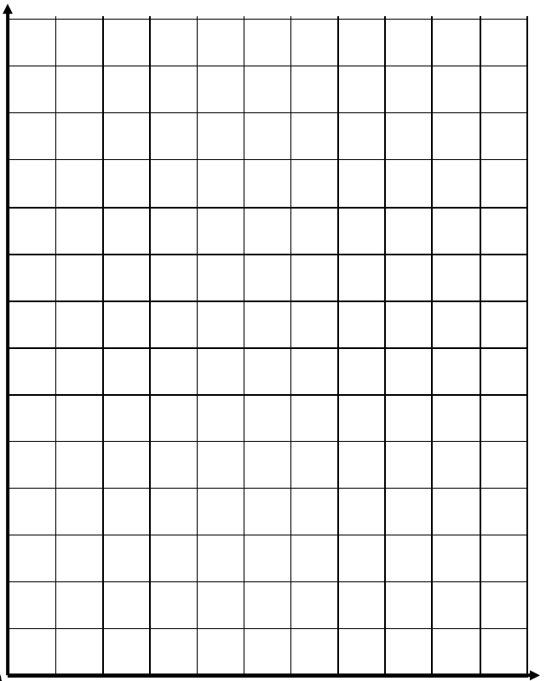

Write an explicit equation for the data in order to calculate the value of deprecation for any year.
Y = initial value (1 – percentage rate of depreciation)^{time}
Y = 20,000(1 - 0.20)^{x}
Y = 20,000(0.80)^{x}
Use this equation to find the depreciated value of the car for year 8.
Y = 20,000(0.80)⁸ = _____________________
When will the depreciated value of the car be worth $5000? _________________
Estimate this value to the nearest tenth of a year with your calculator by inputting the equation in your calculator in Y₁ and 5000 in Y₂ then find the point of intersection (2nd TRACE, 5, ENTER 3 times).

YOUR TURN
Matt bought a new car at a cost of $25,000. The car depreciates approximately 15% of its value each year.
a.) What is the percentage rate of depreciation for the value of this car?
(Remember that the percentage rate of depreciation is 0 < b < 1.)
b.) Write an equation to model the decay value of this car.
y =
where y is the value of the car; x is the number of years since new purchase

c.) What will the car be worth in 10 years?

