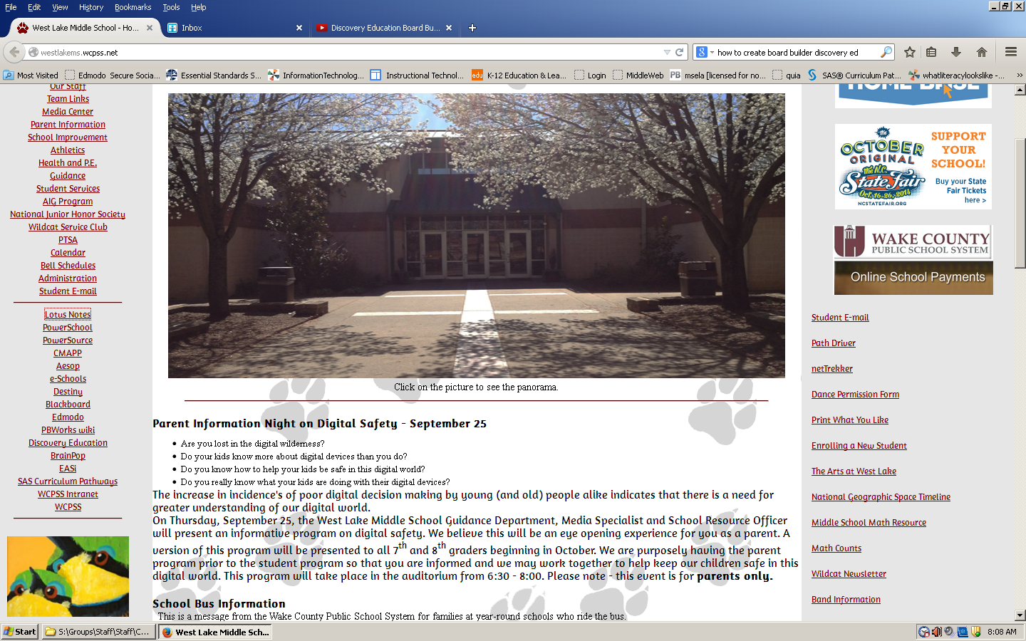

1. Go to the **WLMS home page**
2. **Click** on the Discovery Education Link on the left hand side of web page
3. OR go to www.discoveryeducation.com

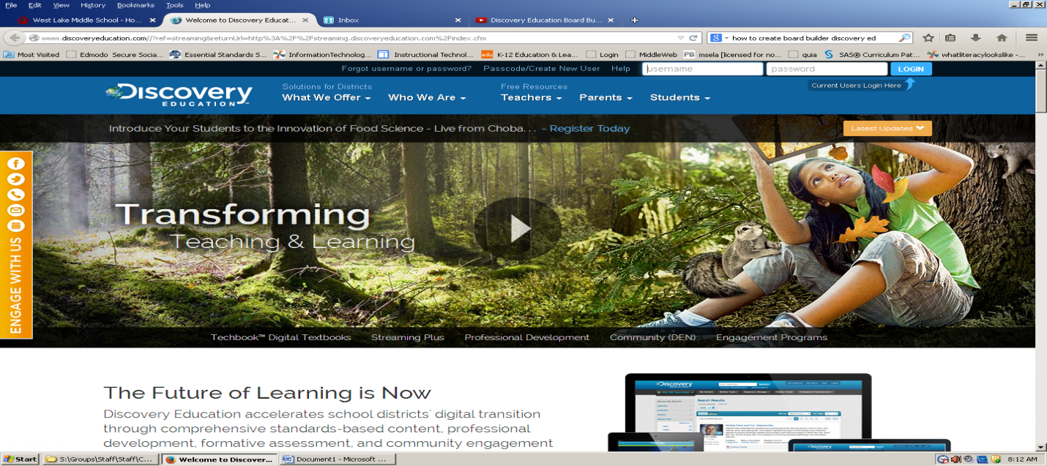

**Log on to Discovery Education** by using:

**Username**: wcp+student ID#

**Password**: student ID#

** Click blue log in button

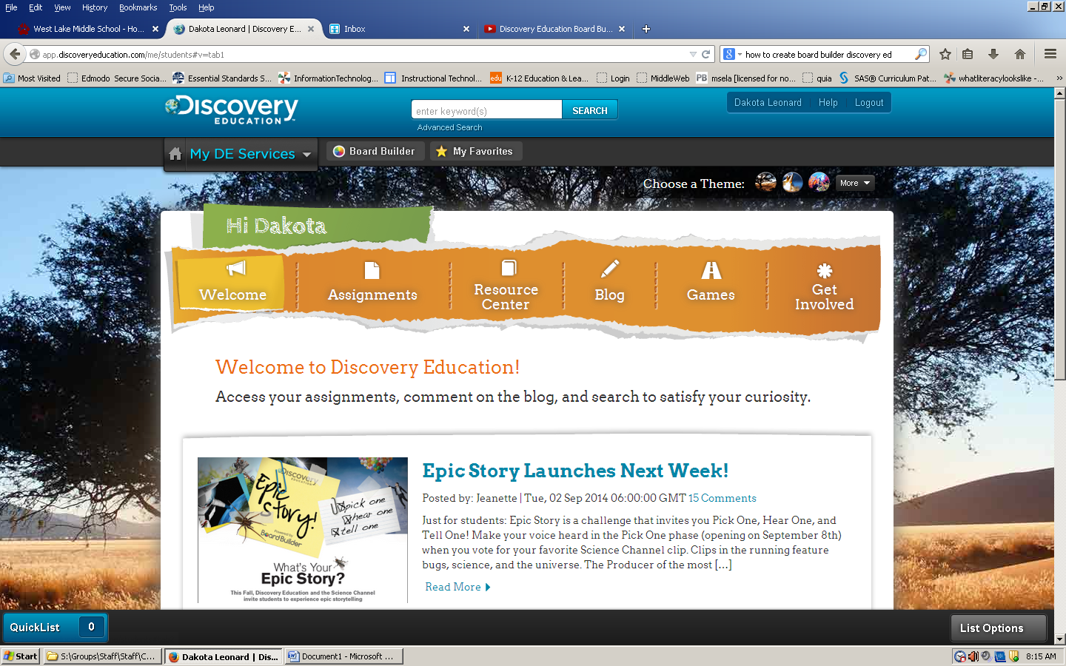

Click on **Board Builder tab** in the gray banner under the Discovery Education logo

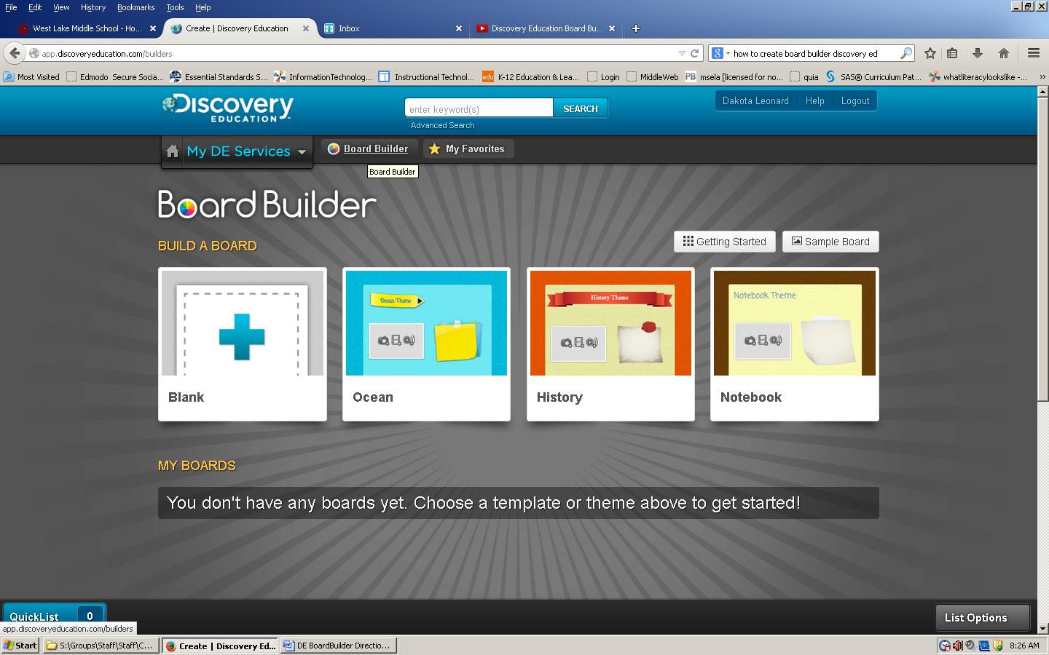

Select a board theme

Click on your choice

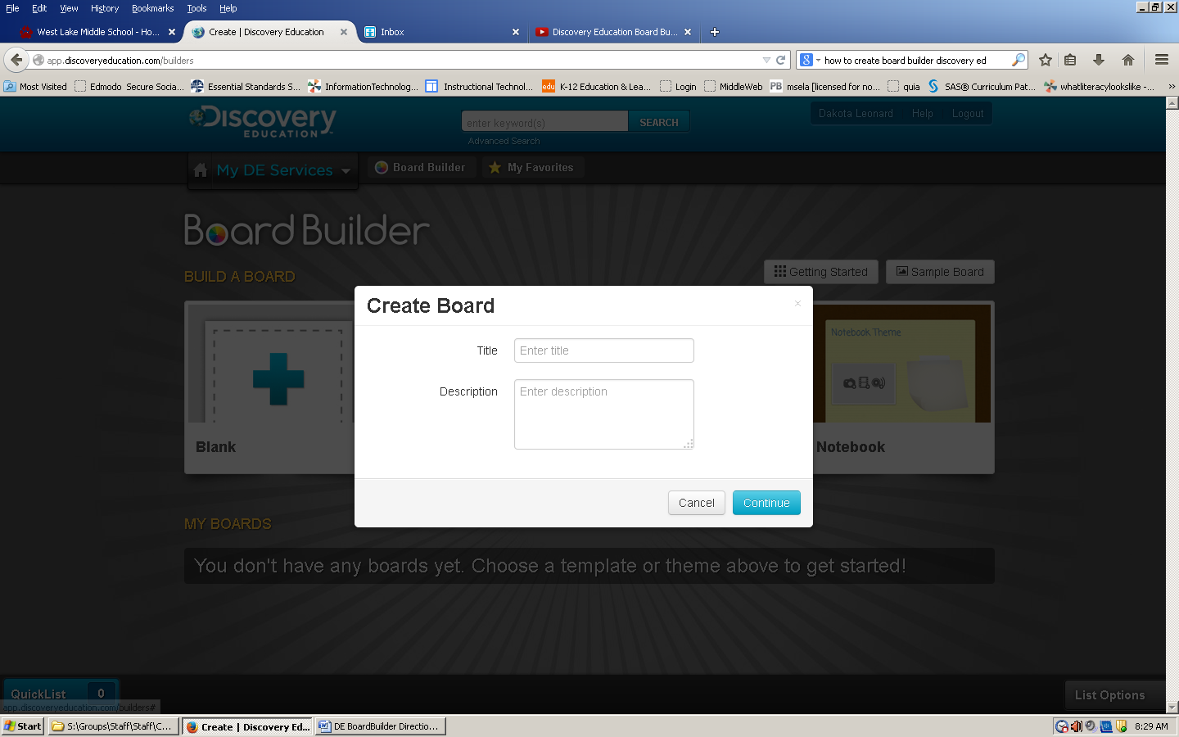

Once you select your board theme you need a title!

(Description box is optional)

Enter a title for your board.

**Click the blue CONTINUE button…**

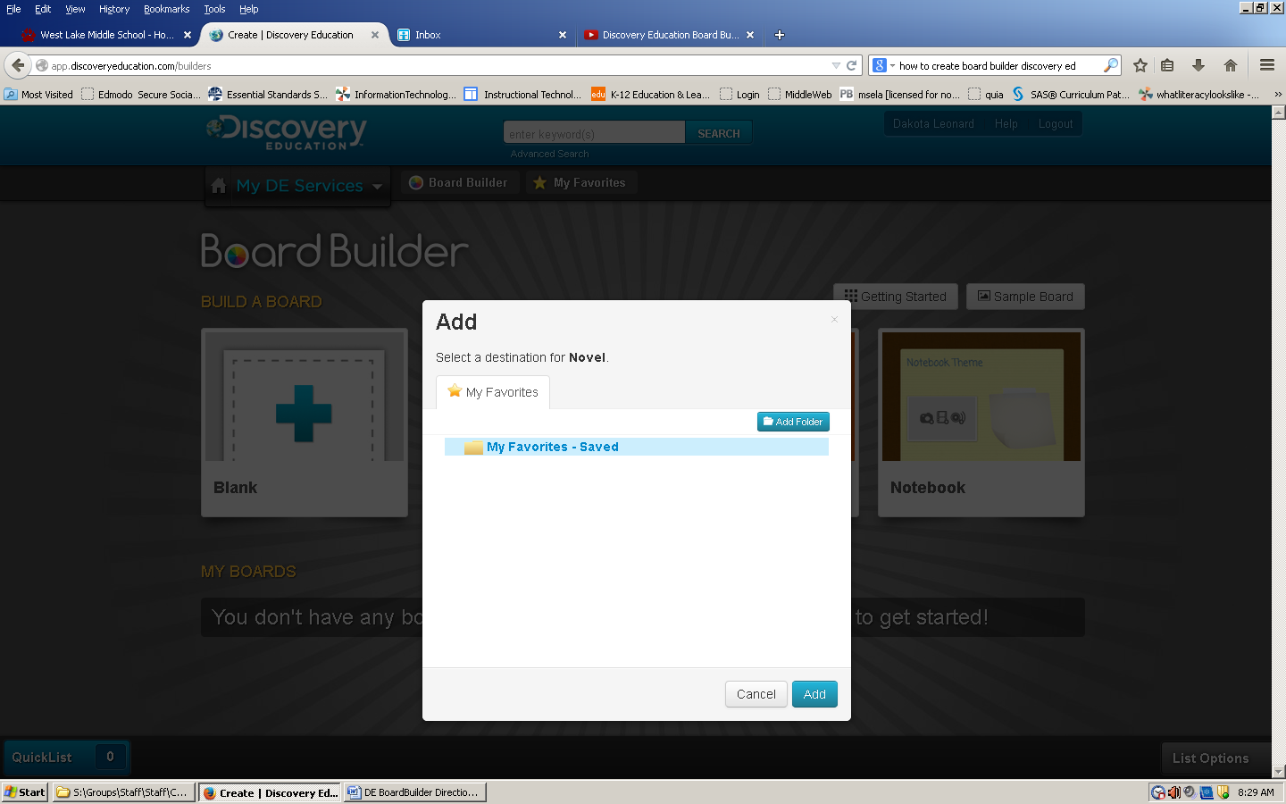

Now you will ADD your Board to your Saved Content…

**CLICK the blue ADD button**

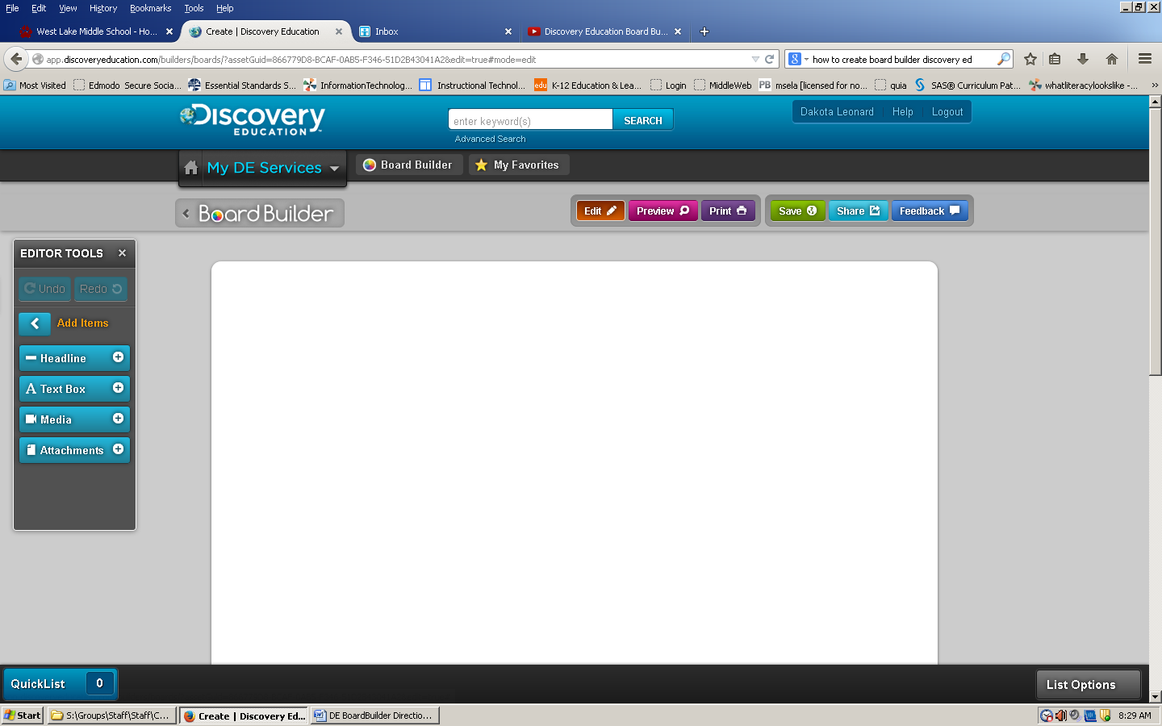

Select the correct box for your board…by adding items

* Text Box
* Media Box (image, video, audio)
* Text Box
* Media Box

Now you can create your BOARD!

Look at your options…

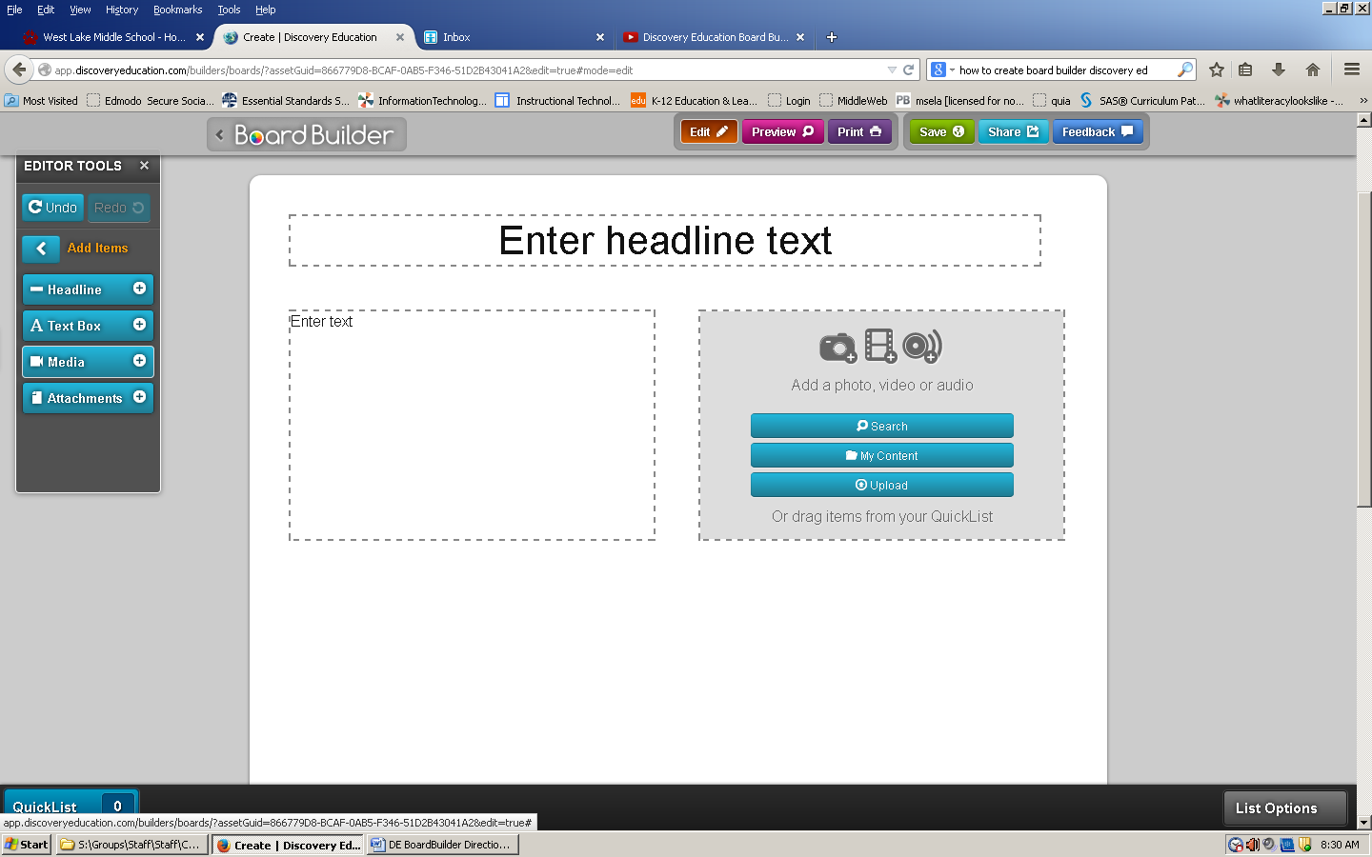

You **can add the following** to your board:

Headline Box

Text Box

Media Box

You can drag and drop boxes within your board!

You can search items in Discovery Education to add to your board.

You can add video, text, audio, etc….

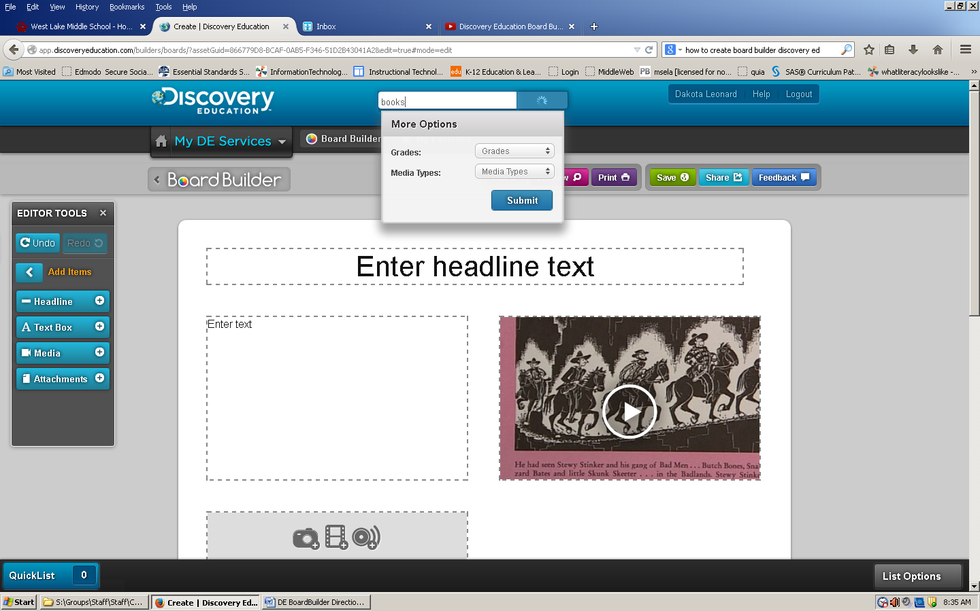

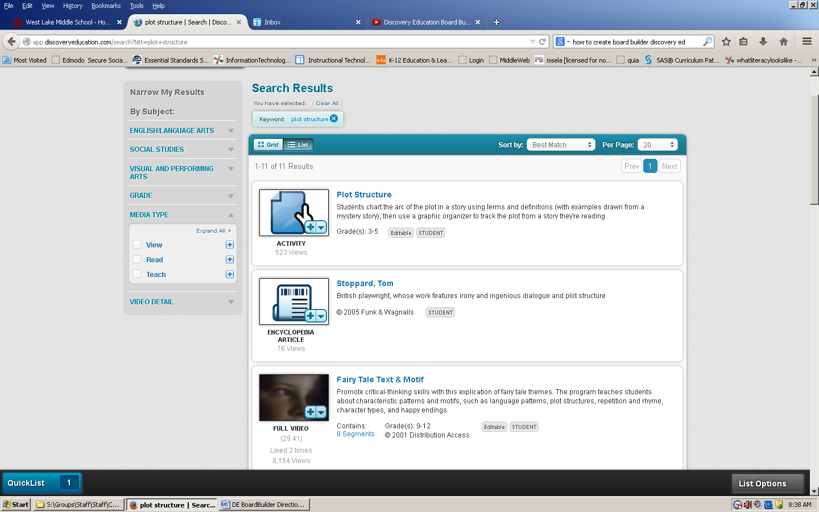

You can save items to your **Quick List** by clicking on the blue plus at the bottom of the picture icon!

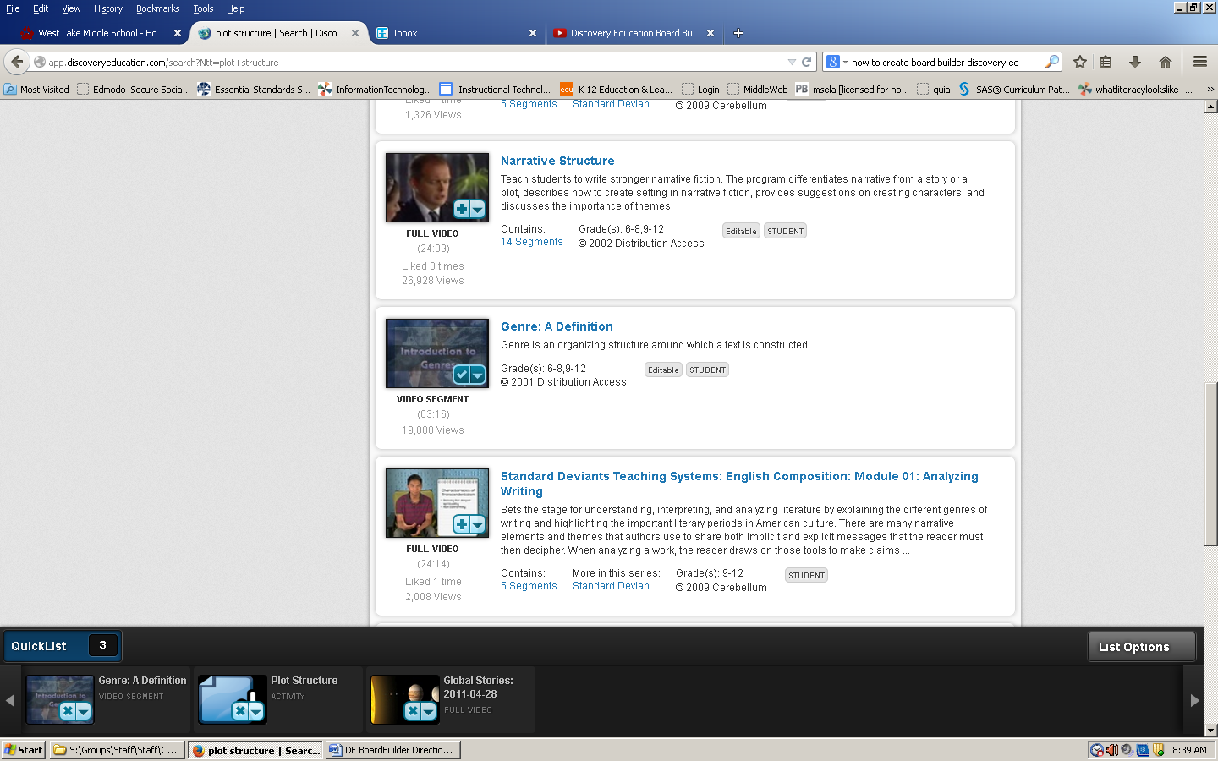

**Quick List**

Once you click on the blue plus to save your items, they will appear at the bottom of your screen in your “QUICK LIST”

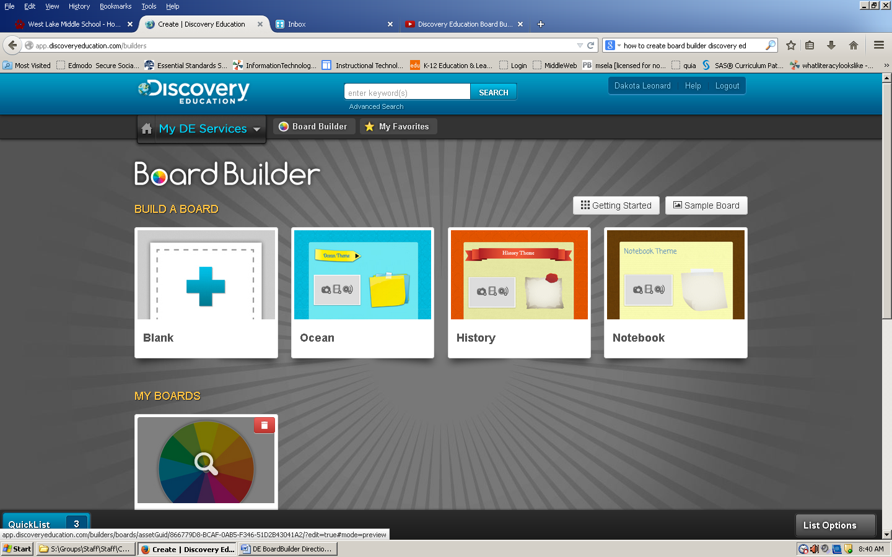

To return to your BOARD…click on Board Builder icon near MY DE Services

Your Board should appear in “MY BOARDS” – Click on your board to open

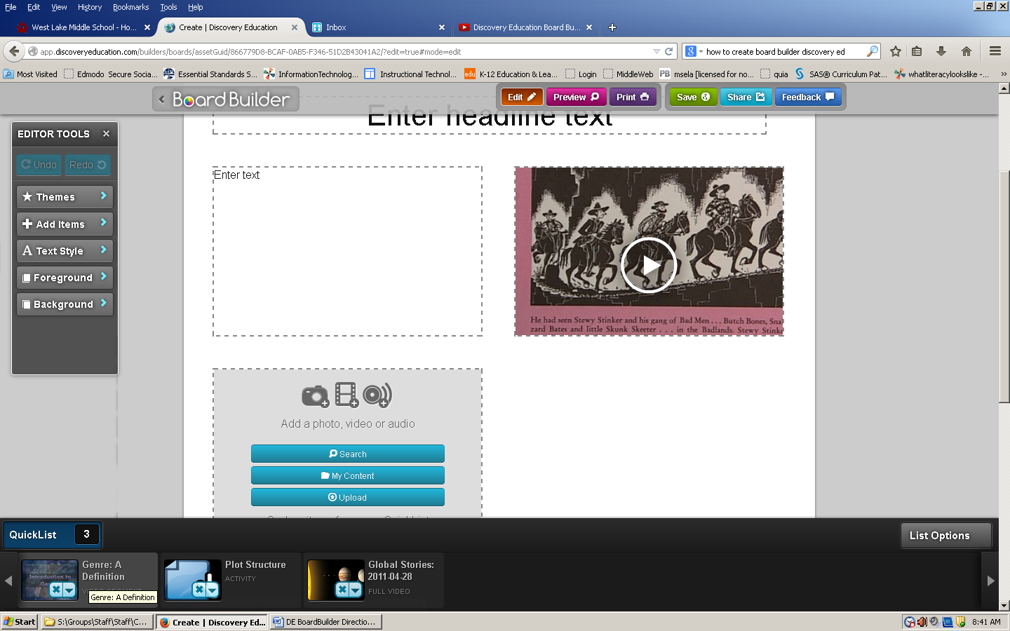

To EDIT your BOARD…

Click on the **ORANGE edit button**

You can drag and drop items to your board from your QUICK LIST

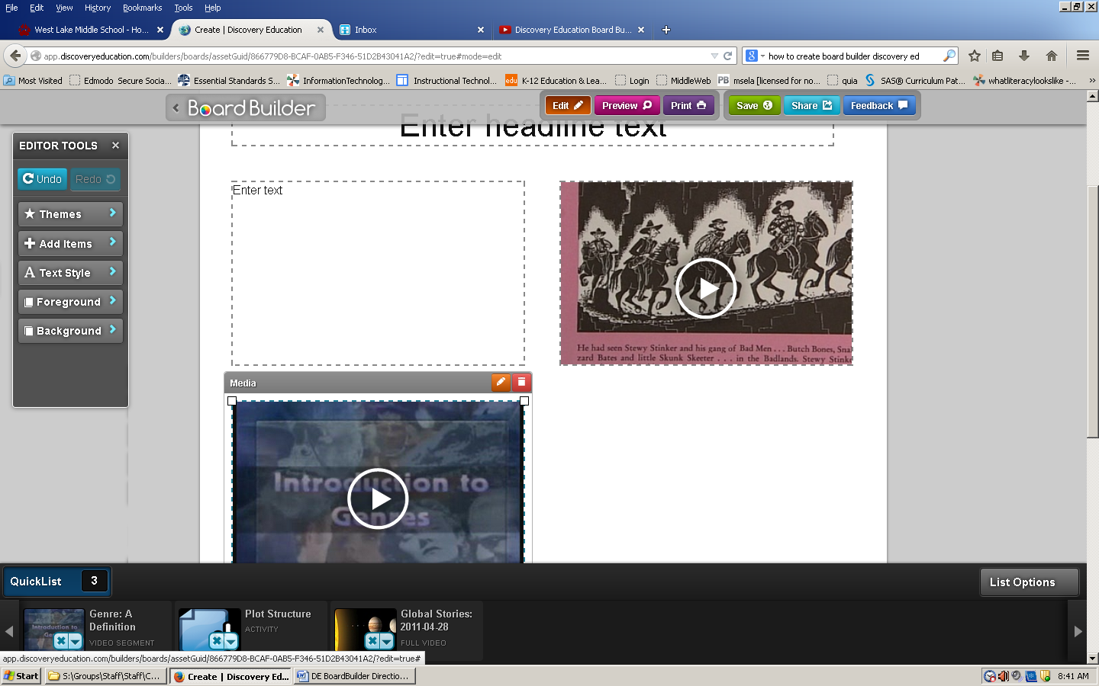

If you do not like a box…you can TRASH the box by clicking on the **RED Trash Can icon on the text box**.

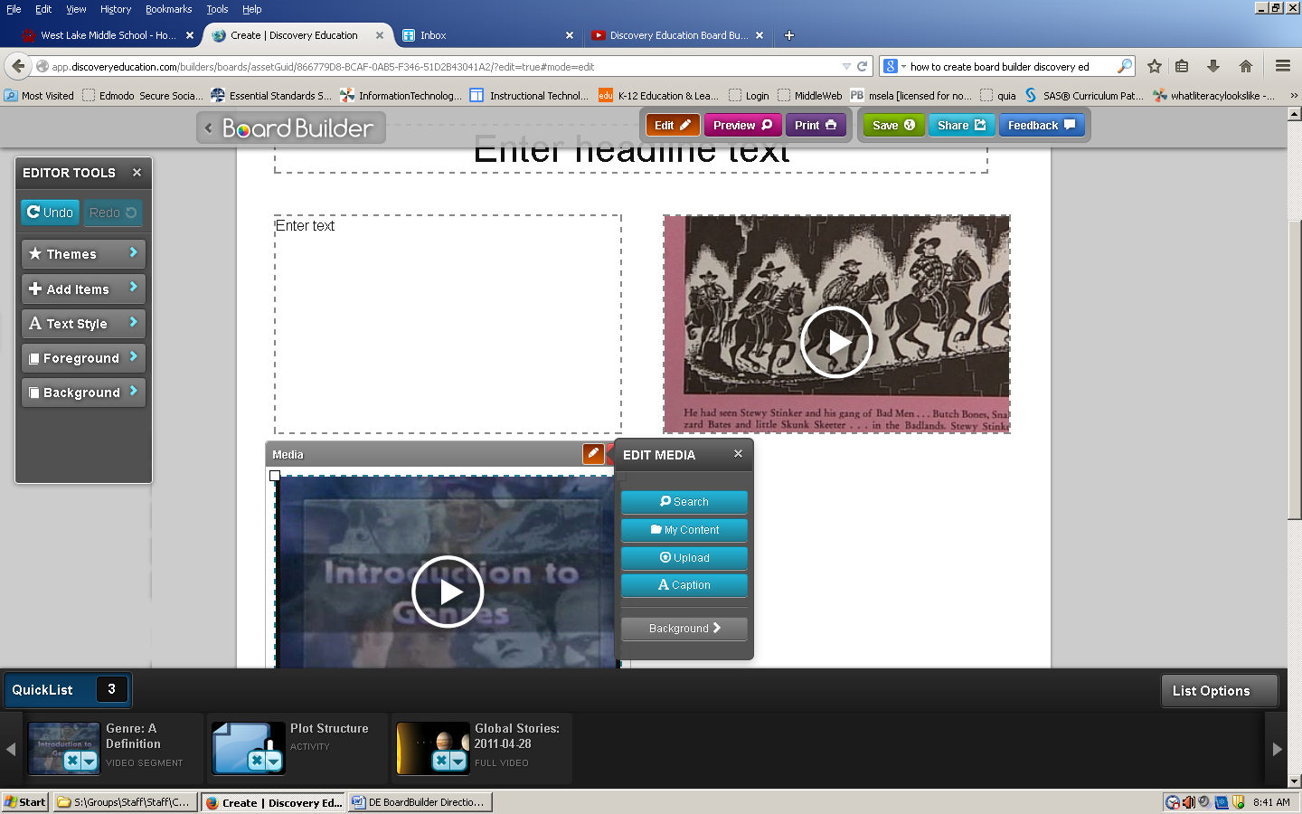

If you want to edit a box to provide a caption…you can click on the ORANGE Pencil Icon on the text box.

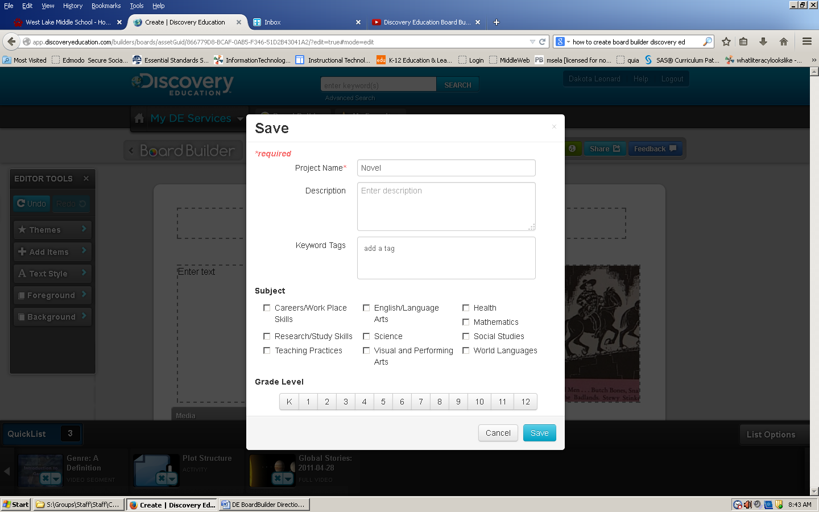

SAVE your BOARD!!!

Click on the **GREEN SAVE** button near the top of the screen!

Complete the boxes as **required**… by

**Naming your board**

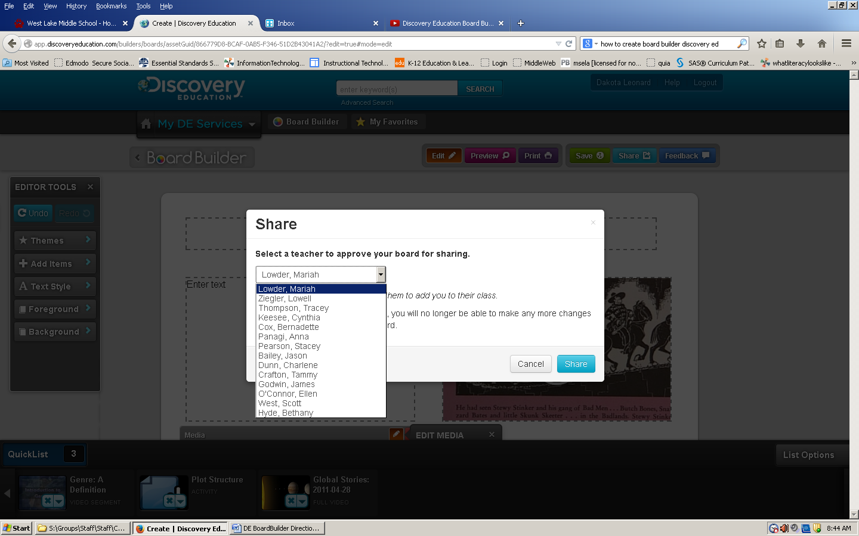

Once your board is complete, you will **SHARE** it with your teacher!

Click on **the light blue SHARE BUTTON** near top of screen!

Once you click SHARE, you will need to **select** the **correct teacher’s name to share your** board!

Now, **Click blue SHARE Button** to send your board to the teacher!

**NOTE:** Once you **share your board**, you will **no longer be able to make any more changes** until your teacher reviews/grades your board.