Name: _________________________
Date: ________ Period: ________
Correlation vs. Causation Notes
A correlation is a measure or degree of relationship between two variables. A set of data can be positively correlated, negatively correlated or not correlated at all. As one set of values increases the other set tends to increase then it is called a positive correlation. As one set of values increases the other set tends to decrease then it is called a negative correlation. If the change in values of one set does not effect the values of the other, then the variables are said to have "no correlation" or zero correlation".
A causal relation between two events exists if the occurrence of the first causes the other. The first event is called the cause and the second event is called the effect. A correlation between two variables does not imply causation. On the other hand, if there is a causal relationship between two variables, they must be correlated.

Example 1: A study shows that there is a negative correlation between a student's anxiety before a test and the student's score on the test.
In other words, the higher the student’s anxiety, the _____________________ the test score.
Causation: Does anxiety cause a student to earn a low test score?
Example 2: A study shows that there is a positive correlation between the number of hours a student spends studying and the student’s score on a test.
In other words, the more hours spent studying, the ___________________________ the test score.
Causation: Does more studying result in a higher grade?
Example 3: Using the graphing calculator, enter the data below.
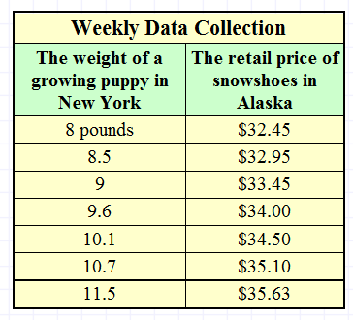
a. Find the equation of the best-fit line.

b. What is the correlation coefficient?

c. Looking at the graph of the scatter plot and the line, describe the correlation. Does this correspond with the correlation coefficient?

d. Correlation vs. Causation: Is this an example of correlation, causation, or both? Justify your answer.

