**Name: ______________________ Class: __________________**

**M8-U8: Notes-HW #2 – Volumes of Composite Figures Date: __________________**

**Find the volume of each composite solid. SHOW ALL WORK!**

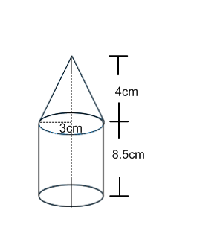**Example 1: Example 2:**

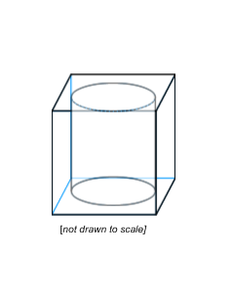**Leave in terms of π.** Nate uses a cube shaped bead with side lengths measuring 6mm. Each bead has a circular hole in the middle. The diameter of the circular hole is 3mm. *Round to the nearest hundredth.*

**Volume = ____________________ Volume ≈ _____________________**

**Practice:**

**Find the volume of each composite solid. SHOW ALL WORK!**

**1.** The hemisphere has a diameter of 15 km. *Round to the nearest tenth.*

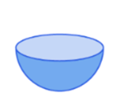*(A hemisphere is a half of a sphere)*

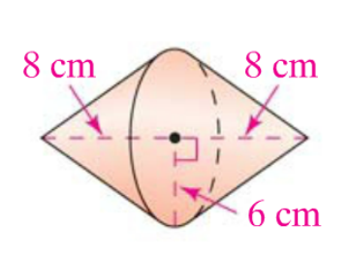**2.** *Leave in terms of π.*

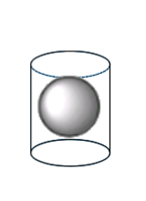

**3.** A ball is inside the cylinder.Find the volume of the empty space inside the cylinder. The height of the cylinder is 6m, the radius of the cylinder is 3m, and the ball has a radius of 3m.

[*not drawn to scale*]

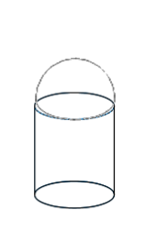**4.** A hemisphere is attached to a cylinder with equal diameter. The cylinder has a diameter of 4.5 inches and a height of 2.5in.*Round to the nearest hundredth.*

**5.** April is filling six identical cones for her piñata. Each cone has a radius of 1.5 inches and height of 9 inches. What is the total volume of the piñata?

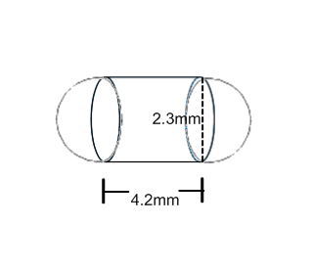

**6.** Here are the dimensions of a pill. *Round to the nearest tenth.*.

**7.** Tanya uses a cube shaped bead with side lengths measuring 12mm. Each bead has a circular hole in the middle. The diameter of the circular hole is 2mm. Find the volume of the bead. *Hint: draw a picture.*

**8.** Three tennis balls are packaged in a box. The box is 12.1cm long, 3.5cm wide and 3.5 cm tall. Each ball is 3.3cm in diameter. What is the volume of the empty space in the box?

**Spiral:**

Evaluate the following:

**9.**  **10.** 

Solve and check the following equation:

**11.** 

**12.** Graph the following linear function: . Identify a solution to the function.