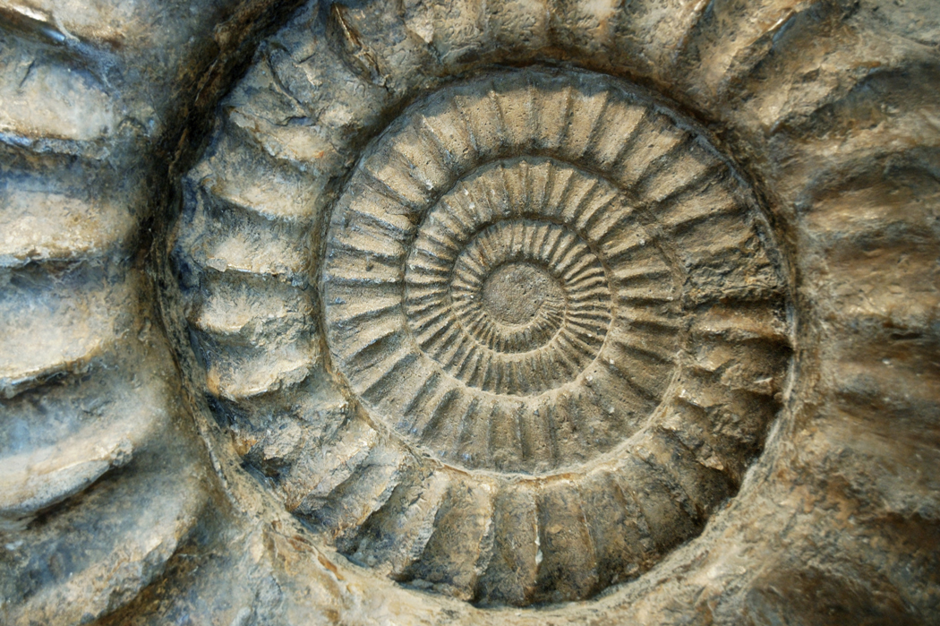
Views of Earth’s Past Guided Notes

- Define fossil.

- List three forms that fossils can take.

- Define original remains.

- List three examples that have provided scientists with original remains.

- How does a fossil form? Use the words “hard remains” and “soft remains” in your explanation.

- Complete the chart below about impressions and traces.
Impression/Trace | Details
Molds/casts
 | Stone fossil of a tree
 | Preserved footprints, trails, animal holes, droppings

- What two things do ice cores show scientists?

- Tree rings give us insight into the weather patterns of the past. How so?

- Define relative age.

- What do disturbed layers look like? How about undisturbed layers?

- What does the Law of Superposition say?

- List three facts about index fossils.

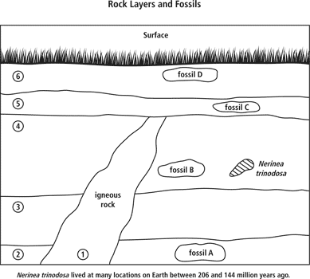

- What does uniformitarianism mean?

- The ______________________ ______________________ ______________________ divides the history of the Earth into

intervals of time defined by ______________________ or ______________________.

- Complete the outline below regarding the divisions of time.
  - Hadean Eon
  - ______________________ Eon
  - Proterozoic Eon
  - ______________________ Eon
    - ______________________ Era
    - ______________________ Era
    - Cenozoic ______________________

- Eras are divided into ______________________ . An ______________________ refers to a subdivision of the Cenozoic era’s periods.

- Which three eons together comprise the Precambrian?

- What does “Precambrian” mean?

- The ______________________ eon spans from ______________________ time until present day.

- “Paleozoic” means ______________________ life, while “Mesozoic” means ______________________ life and

______________________ means recent life.

- When did the first mammals appear?

- When did dinosaurs live?

- What major life form first appeared in the Cenozoic era?

