Classwork – Systems of Equations Review Name: _________________________________
Use this review to help you complete test corrections. Test corrections are due on Friday, May 19th!
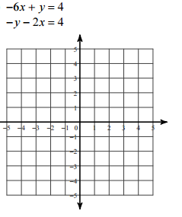
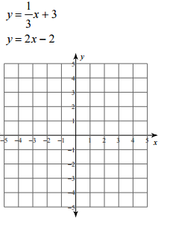
Solve the systems by GRAPHING. Remember, equations must be in slope-intercept form!
1. m = ____, b = ____ 2. m = ____, b = ____
m = ____, b = ____ m = ____, b = ____

Solve the systems by SUBSTITUTION.
3. 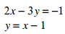 4. 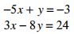

Solve the systems by ELIMINATION.
5. 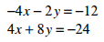 6. 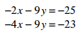

7. Use your calculator to check your work for EACH system:
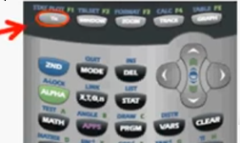
Step 1. Get BOTH equations into slope-intercept form.
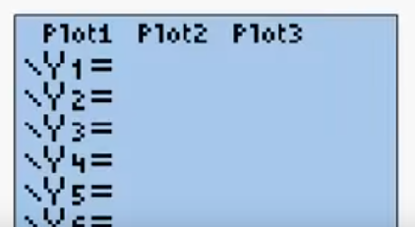
Step 2. Enter the equations as y₁ and y₂.
*Make sure Plot1, Plot2, Plot3 are turned
OFF (they should NOT be highlighted)

Step 3. Press Graph.
Step 4. You should see your two lines on the graph. If you do not: Press Zoom 7. Standard
Step 5. Press 2nd Trace to access CALC.
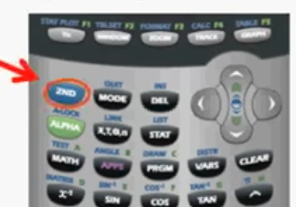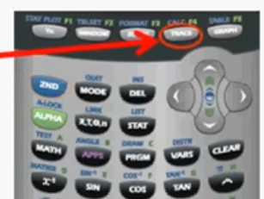
Step 6. Under the CALCULATE menu, select 5: intersect
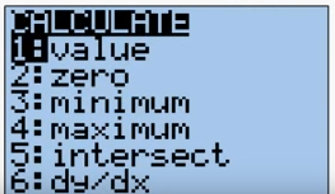
Step 7. You now have to “tell” your calculator which lines to use. You should see the trace point on one of the lines, your calculator will display
First curve? HIT ENTER.
Second curve? HIT ENTER.
Guess? HIT ENTER.
Step 8. The intersection will be given as x = ___ and y = ____. Write them as a point (x,y). DONE!

