Slope Investigation
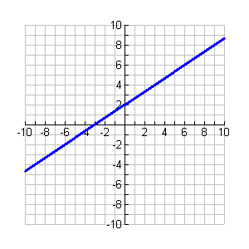
Exploration 1. Refer to the graph at the right and points below.
Points: Set 1 (0, 2), (0, 4), (3, 4)
Set 2 (3, 4), (3, 8), (9, 8)
Set 3 (3, 4), (3, 6), (6, 6)
Set 4 (-3, 0), (-3, 4), (3, 4)
1. Choose two sets of points and connect the points from each set.
2. What geometric figures are formed by connecting the points?

3. Are the two figures similar? How do you know?

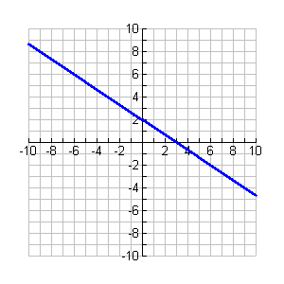
Exploration 2. Use the graph at the right.
- Following the process from above, pick any points to make two similar triangles.

- Determine the ratio of the leg lengths for each triangle. Are the two triangles similar? How do you know?

- What is similar about this line and side length ratio
and the results you found in Exploration 1? What is different about the lines?

****Slope is the ratio of the vertical side length to the horizontal side length of your triangles. $slope=\frac{Δy}{Δx}$
- What is the slope of the line in Exploration 1? _____ What is the slope of the line in Exploration 2? _____
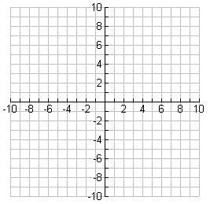
Tying it together…
- If the ratio of the vertical side length to the horizontal side length of each triangle formed by a line is $\frac{1}{5}$, find three possible points on the line. Justify your answer.

- How could you create a slope of $\frac{-1}{2}$?

