Slave Histomatics
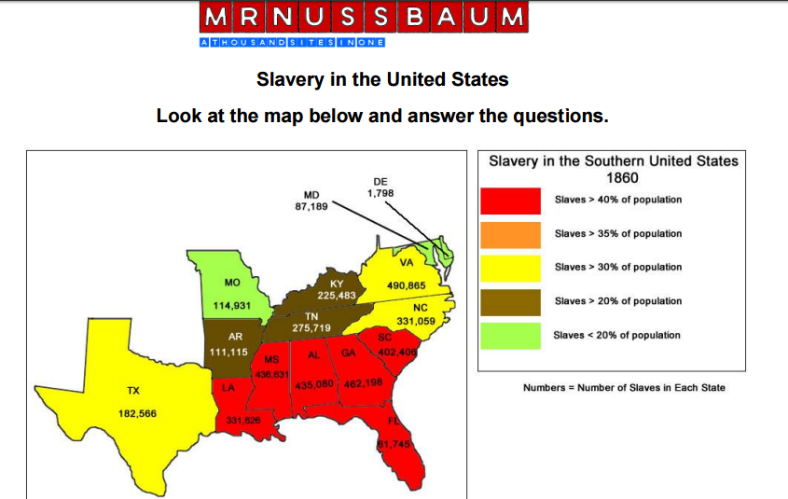
file:///C:/Users/cevans5/Dropbox/US%20History/Civil%20War/Slave%20Histomatics%20Worksheet.pdf

