Standard(s):
8.F.1
Questions | Answers
- Identify the following relation as a Function or Not a Function:  $$x^{2}+y^{2}=49$$ | - Not a Function
2. Identify the following relation as a Function or Not a Function: | - Not a function
3. Identify the following relation as a Function or Not a Function: | - Function
- Identify the following relation as a Function or Not a Function:  (-3, 2) (4, 2) (6, 2) (-1, 2) (5,2) | 4. Function
5. Identify the following relation as a Function or Not a Function: | - Not a Function

Standard(s):
8.F.2
Questions | Answers
1. Identify which function has a negative rate of change:  Function 1:  Jane was given fifty dollars for her birthday. Every week she spends $2.50 on snacks at lunch. Let y represent the amount of money she has as a function of x, the number of weeks.  Function 2:  Ivan has been collecting model cars for several years. He currently has sixteen model cars. He makes two new model cars each year. Let y represent the number of model cars, as a function of the number of years collecting, x. | 1. Function 1
- Which function has the greatest rate of change?  Function 1:  Function 2:  $$y=-\frac{1}{2}x+5$$ | 2. Function 1: $-\frac{1}{3}$  Function 2: $-\frac{1}{2}$  Function 1 has the greatest rate of change.
- Thomas and Tanner mow lawns to earn money during the summer. The functions below represent the amount of money they earn per lawn. Both boys charge a fee for transporting their equipment plus a certain amount per acre of land they mow. Let y represent the amount earned, for each acre of land they mow, x.  Thomas: y = 6x + 6 Tanner:  Who charges more to mow an acre of land? Who has the larger transportation charge? | - Thomas charges the most per acre. Thomas charges $6 per acre, but his transportation fee is less. Tanner charges $4 per acre, but has a $10 transportation fee. Tanner has the larger transportation fee.
4. Compare the cost of bananas at the following stores:  - Store A sells bananas for 5lb. of bananas for $2.85.  - Store B sells bananas at the following rate:  If Janet needs three pounds of bananas for a banana pudding, which store should she go to for the cheapest price? How much will she save at this store? | - Store 1: $0.57 per pound  Store 2: $0.50 per pound  Janet should buy her bananas at Store 2. She will save $0.21.
5. A candle burns at a rate of  $y=-1.5x+10$, where y is the height of the candle after burning x hours.  Write a function rule for a 10 inch candle that burns faster than the candle above. | 5.Answers will vary. Students should write a function rule with a y-intercept of 10 and a negative rate of change, which has an absolute value greater than 1.5.

Standard(s):
8.F.5
Questions | Answers
- On the coordinate grid below, sketch a graph of a continuous function that  - is increasing and nonlinear from x = –4 to x = 0  - is linear and has a negative slope from x = 0 to x = 4,  - and is decreasing and nonlinear from x = 4 to x = 10.  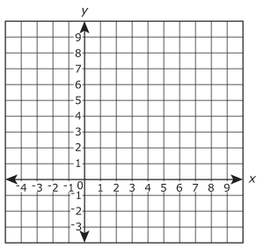 | - Answers will vary. Ensure students know the difference between linear and nonlinear, and increasing and decreasing.
- The graph below shows Joshua’s travels to school each day. Describe Joshua’s trip to school. | Answers will vary. Sample answer: Joshua walks to the bus stop, he stops and waits for the bus, and then he rides the bus to school.
- Is the function below linear or non-linear? Name the x-interval of the function that is decreasing. | 3. Non-Linear. The function is decreasing from x = -3 to x =4.
- When the stop light turns green, Jordan accelerates, until he reaches 5 miles over the speed limit. He decreases his speed to the speed limit and then drives at a constant rate. Draw a speed-time graph that represents this situation.  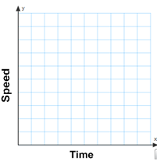 | 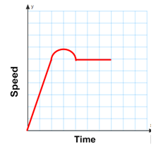

- On the coordinate grid below, sketch a graph of a continuous function that  - is decreasing and linear from  x = –4 to x = -2  - is linear and has a positive slope from x = -2to x = 2  - is decreasing and nonlinear from x = 2 to x = 5.  - and is increasing and linear from  x = 5 to x = 10. | 5. Answers will vary. Ensure students know the difference between linear and linear, and increasing and decreasing.

