Name: ___________________

Notes: The Roaring Twenties: Culture
1920’S POWERPOINT

Answer the questions and fill in the blanks from the Powerpoint.
Politics and Prosperity in America
(The Boom before the Bust)
1. What were the roles of women during WWI?

2. How did this change at the end of WWI?

3. Politically: A return to ___________ after WWI

4. What types of changes were brought about in the 1920’s?
- _____________
- _____________
- _____________
5. What are SOCIAL changes?
- People’s ___________
- The way people ___________ with one another
- Society as a ___________

6. What is economic change?
- Changes in the production, ____________, and ___________ of goods and services

7. What is political change?
- Change in the ______________
- The way people think about ______________
- Change in _______

Now let’s look at some of the SOCIAL changes that
took place in the 1920’s

MOVIES

8. How did movies change in the 1920’s?
- From silent movies to _______________
- View the silent film clip: https://www.youtube.com/watch?v=Bp3uGJu-kIE (Clip is on the PowerPoint as well so you can click.)
- Were silent films actually completely silent? ____ What did they lack? _______
- Some famous silent movie stars include:

9. What was the first “talkie”?
- The _________ Singer
- Pretty appropriate for the decade, why? _______________________
- Let’s watch a little clip from this first talkie movie… Nothing like going to the movies today! https://www.youtube.com/watch?v=fEvuIKhuHuQ
- Even _______________ started talking during this time period (in 1927)!
- He made his talking debut as ____________
- Let’s watch a clip from his first talking cartoon: https://www.youtube.com/watch?v=7NQyzcDnMdE

MUSIC: The JAZZ AGE

10. What was the new kind of music and what was different about it?
- Called The Jazz Age because of Jazz!
- A ________ paced style
- The first ________ music of the United States. Why is this important for U.S. culture?

11. Who founded this music?
- Started by ____________ in ___________

12. Who were two famous musicians of the time?
- Louis ____________
- Bessie _____________
- Let’s listen to a couple clips from their songs
https://www.youtube.com/watch?v=YtElKZHRISg
https://www.youtube.com/watch?v=DCpGx4Xgb-o

DANCE

13. What was the new dance that kept pace with the new music?
- The ________________
- A dance that kept pace with the ________ music
- Let’s watch a clip of the Charleston… https://www.youtube.com/watch?v=SJ70THdDnew

WOMEN AND FASHION

14. Define flapper: _____________________________________________
15. What changed about women in the 1920’s?
- The Trend: the skirts and dresses grew ___________ and sleeker, along with their hair! Short hair, short skirts and wanted to dance
- Women were nicknamed ____________: this signified the new independence of women

16. How did these young women offend the older generation?
- Flappers offended the older generation because she defied conventions of _________________ (aka traditional behavior)

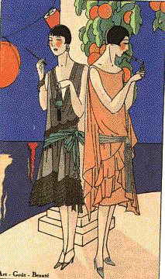
17. What aspects of flappers are shown in the drawing?
List them all below…

Flappers video: https://www.youtube.com/watch?v=QegIgnarTH4

HARLEM

RENAISSANCE

18. What was the Harlem Renaissance?
- Rebirth of ______________ Culture
  - Through intellect and production of ____________, art, and __________, African-Americans could challenge racism and __________ to promote racial and social integration.

Watch the brainpop on the Harlem Renaissance and answer:
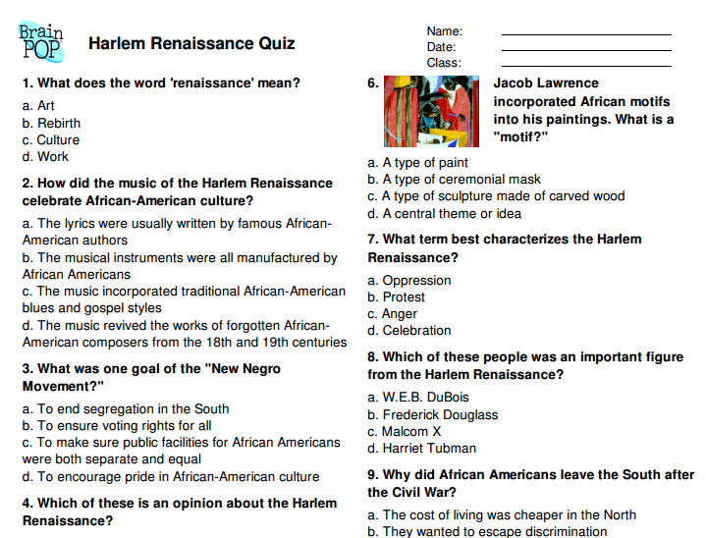
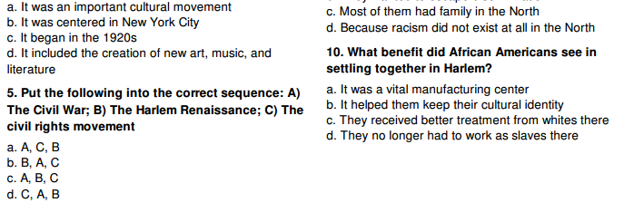

19. Who was a poet of the Harlem Renaissance?
- Poet _________ Hughes
- One of his most famous poems was titled ________

20. Read the poem
What is the message? __________________________________________________________________

Dreams
By Langston Hughes

Hold fast to dreams
For if dreams die
Life is a broken-winged bird
That cannot fly.
Hold fast to dreams
For when dreams go
Life is a barren field
Frozen with snow
21. Who was an artist of the Harlem Renaissance?
- The artist Williams H. _____________
- Johnson painted thousands of pictures, many of which are now on display in the _______________ in Washington DC

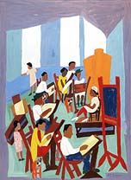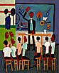

22. Who was a famous singer of the Harlem Renaissance?
- Singer __________ Holiday
- Yes she was a girl….
- Let’s listen to her sing one of her most famous songs: Strange Fruit https://www.youtube.com/watch?v=h4ZyuULy9zs
STRANGE FRUIT
Southern trees bear a strange fruit
Blood on the leaves
Blood at the root
Black bodies swinging in the southern breeze
Strange fruit hanging from the poplar trees
Pastoral scene of the gallant South
The bulging eyes and the twisted mouth
The scent of magnolia sweet and fresh
Then the sudden smell of burning flesh
Here is a fruit for the crows to pluck
For the rain to gather
For the wind to suck
For the sun to rot
For the tree to drop
Here is a strange and bitter crop
Lyrics by: Lewis Anderson
Originally sung by: Billie Holiday

23. What do you think Strange Fruit was about? _________________________________________________________________________________________________________________________________________________________________________________________________________

THE GOLDEN
AGE OF SPORTS

24. Who were some of the sports greats in the 1920’s and their sports?
- BASEBALL: _____________, 60 home runs in 1927, played most of his career for the New York Yankees
- GOLF: ______________, Started “The Masters”, competition that still exists today for golf
- TENNIS: _________________
- COLLEGE FOOTBALL: _________, the “galloping ghost”, ________ Rockne,
- SWIMMING: _______________, swims the English channel in 1927.

RADIO

25. When was the first radio broadcast?
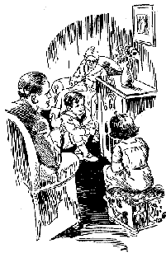
- The first radio station was KDKA Broadcast and it had its first broadcast on November 20, _________

26. Why was the radio important?
- Radio provided for the whole ___________
- Entertainment, __________ and _________

FADS: 1920’s
The Wonderful Age of Nonsense

Define fad: ________________________________________________
27. What were some of the new fads of the 1920’s?
- Marathon Dancing: _____________, the last couple standing wins! These could usually last for _________!
- Flagpole _________: Record: Shipwreck Kelly, _______, sat for almost 13 hours!!

Literature
Famous authors from this time period include:
- Ernest _________: A passionate young author who used history and experience to write his books, including A Farwell to Arms (about WWI), The Old Man and the Sea
- F.Scott __________: A young author who best captured the mood of the Roaring Twenties, including The Great Gatsby, The Curious Case of Benjamin Button

“Goodbye WWI…..Hello Roaring 20’s !”

Read AND ANNOTATE the following introduction to the Roaring 20’s:
The “Roaring Twenties” was a decade in which nothing big happened—there were no major catastrophes or large events—at least until the stock market crash of 1929—yet it is one of the most significant decades in U.S. history because of the great changes that came about in American society. The Twenties were known by various images and names: the Jazz Age, the age of the Lost Generation, flaming youth, flappers, radio and movies, bathtub gin, the speakeasy, organized crime, confession magazines, Hemingway and Fitzgerald, Charles Lindbergh, Babe Ruth, Bobby Jones, the Great Crash, Sacco and Vanzetti, Al Smith, cosmetics, Freud, the “new” woman, the Harlem Renaissance, consumerism—all these images and more are part of the fabulous Twenties!
The 1920s provided something of a roller coaster ride for the American people. The euphoria surrounding the end of World War I was clouded by the great flu epidemic of 1919, the Red Scare of that year, and the frustration and bitterness left over from the fight over the ratification of the Treaty of Versailles. The progress made toward reform under progressive Presidents Roosevelt and Wilson slowed to a crawl, as many Americans began to feel the need for a break from the moral intensity of the Progressive Era.
The 1920 election resulted in a Republican landslide. Harding/Coolidge received 16,152,200 popular votes and 404 electoral votes compared with Cox/Roosevelt totals of 9,147,353 popular votes and 127 electoral votes. Most memorable about the election of 1920 is that for the first time women had the right to vote.
Though the Twenties was a decade of enormous social change, myths about the era sometimes exaggerate the reality of that strange and often troubling time. While consumerism boomed and many new inventions—radios and telephones, for example—became everyday items for many Americans, it was also a time of much bitterness, conflict, and disappointment. The economic boom left many in the dust, America’s traditional openness to immigration was severely cut back, and racial tensions rose. Prohibition, the “noble experiment,” caused ordinary citizens to resort to criminal behavior, even as government often winked and looked the other way.
Following the Great War, as the only major Western nation not devastated by that conflict, Americans felt pretty good about themselves. The continued economic growth, political conservatism, and general absence of concerns over foreign affairs led Americans to think of themselves as “having it made.” Proof of America’s spirit and achievements seemed to be personified by Charles Lindbergh as he made his historic flight from New York to Paris in 1927. But the 1920s also saw deep divisions in the country despite the “roaring” atmosphere brought about by bathtub gin, speakeasies, flappers, women voting, jazz, sports, and all the rest. Then at the end of that self-satisfied, raucous, and somewhat grumpy decade, when the expectations of many Americans knew no bounds, the stock market crashed and the Great Depression hit.
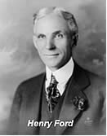
During the 1920s everybody seemed to be buying everything, and businesses set out to meet the demands of consumers, producing new products in record-breaking quantities. Cars, radios, appliances, ready-made clothes, gadgets, and other consumer products found their way into more and more American homes and garages. Americans also started buying stocks in greater numbers, providing capital to already booming companies. All the signs pointed upward, and starry-eyed men and women began to believe that it was going to be a one-way trip, possibly forever.
Henry Ford’s assembly line not only revolutionized production, it democratized the ownership of the automobile. Ford showed that handsome profits could be made on small margin and high volume. By 1925 his famous Model T sold for less than $300, a modest price by the standards of the 1920s. Americans had never had it so good. (Many, of course, would not have it so good again for a long time

The Twenties were also known as a time of revolution in manners and morals, when young men, and especially young women, threw off many of the social restrictions of the Victorian era and began conducting themselves in ways that scandalized the older generations. Young women liberated themselves in everything from hairstyles and clothing to deportment and public behavior, smoking cigarettes and drinking from flasks of illegal bootleg whiskey and bathtub gin. The ’20s were known as the jazz age and saw the rebirth of the Ku Klux Klan, divisions between town and country that went beyond mere style, the Harlem Renaissance, an enormous growth in production of items such as automobiles once seen as luxuries, and a general feeling of near euphoria, as if for the middle and wealthy classes, at least, things would just keep going up.
The Twenties were in another sense a reactionary decade—a reaction against Victorian ideas of morality that saw young men and women openly defy what their parents still viewed as proper behavior for relationships between the sexes. Young people went wild, in the eyes of some, though studies have suggested that there was more talk than action. It was also a rebellious age, in which women continued the process of breaking out of older social patterns as they had begun to do during World War I. They changed their dress styles, cut their hair short, smoked in public, and were not above taking a nip from a flask of Prohibition whiskey.
Based on the Reading: Fill in how the following changed during the 1920’s. LIST as many examples as you can find from the reading…

Automobile  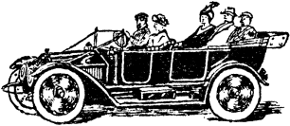 | Women | 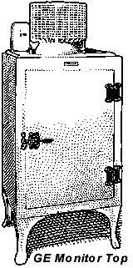  Appliances
 |  | What’s installment buying?

