**C:\Documents and Settings\kkelley\Local Settings\Temporary Internet Files\Content.IE5\UQWTZD9I\MC900388748[1].wmfGuided Practice with Depreciation Problems**

Other vehicles and equipment depreciate over time as well, such as trucks, boats, tractors, computer equipment, etc. Let us look at other items which depreciate over time. The cost of a new truck is $32,000. It depreciates at a rate of 15% per year. This means that it loses 15% of each value each year.

Tasks:

* Draw the graph of the truck’s value against time in year.
* Find the formula that gives the value of the truck in terms of time.
* Find the value of the truck when it is four years old.
* Estimate when the truck will be worth half of its value (about $16,000).

Let’s start by making a table of values. To fill in the values we start with 32,000 at time *t* = 0. Then we multiply the value of the car by 85% for each passing year. (Since the car looses 15% of its value, which means that it keeps 85% of its value). Remember that 85% means that we multiply by the decimal 0.85.

|  |  |  |  |  |  |  |
| --- | --- | --- | --- | --- | --- | --- |
| **Number of Years** | 0 | 1 | 2 | 3 | 4 | 5 |
| **Value of the Truck** | 32,000 |  |  |  |  |  |

Graph the data on the coordinate grid below. Remember to label your axes.

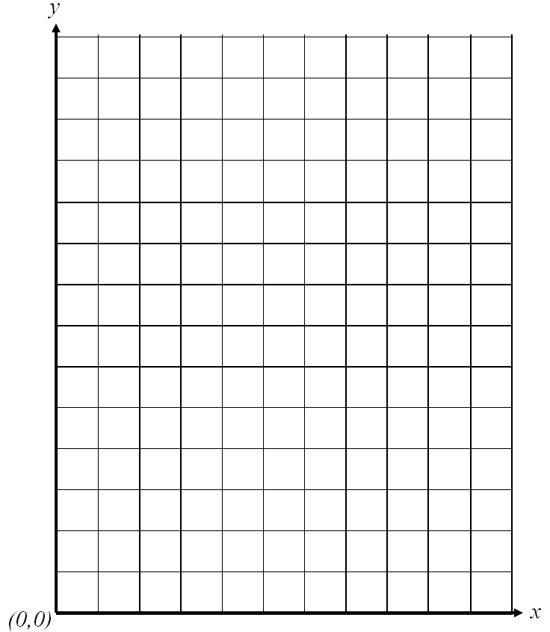

Now let us write the equation for the data.

Initial value: ____________

Percentage rate of depreciation: ______

Equation: ___________________________

Use the equation to determine the value of the truck when it is 4 years old.

Value of the 4 year old truck: ____________

Compare this value with the value in the data table. It should be the same value if your equation is correct.

Use the table, graph, equation, or graphing calculator to estimate the time it will take for the truck to worth half of its initial value. _____________________________

**Try a few more:**

1. The cost of a new ATV (all-terrain vehicle) is $7200. It depreciates at 18% per year. Draw the graph of the vehicle’s value against time in years. Find the formula that gives the value of the ATV in terms of time. Find the value of the ATV when it is ten year old.

|  |  |
| --- | --- |
| **Number of Years** | **Value of the ATV** |
| **1** |  |
| **2** |  |
| **3** |  |
| **4** |  |
| **5** |  |



1. A tool & die business purchased a piece of equipment of $250,000. The value of the

equipment depreciates at a rate of 12% a yr.

1. Write an exponential decay equation for the value of equipment.
2. What is the value of equipment after 5 years?
3. Make a table and graph the model.

|  |  |
| --- | --- |
| **Number of Years** | **Value of the Equipment** |
| **1** |  |
| **2** |  |
| **3** |  |
| **4** |  |
| **5** |  |



d. Estimate when the equipment will have a value of $70,000.