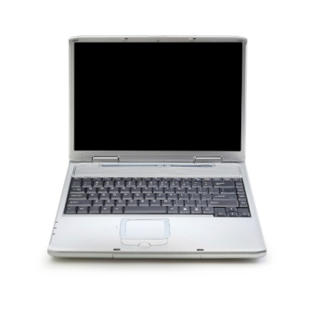
Independent Practice with Depreciation Problems
Use equations, graph, or tables to find the solutions to the problems below.
- A computer valued at $6500 depreciates at the rate of 14.3% per year. Write a function that models the value of the computer. Find the value of the computer after three years.

- A new truck that sells for $29,000 depreciates 12% each year. Write a function that models the value of the truck. Find the value of the truck after 7 years.

- A new car that sells for $18,000 depreciates 25% each year. Write a function that models the value of the car. Find the value of the car after 4 years.

- You purchased a car for $19,500. The car will depreciate at a rate of 12% each year. Write a formula to represent the value of the car after x number of years. Find the value of the car after 4 years.

- Each graph below shows the expected decrease in a car’s value over the next five years. Write a function to model each car’s depreciation. Determine which car will be worth more after 10 years.

