Energy Piktochart Assignment
Test Grade: Due on Friday, March 17

Use the Intermediate Energy Infobook as your ONLY source of information. No Google searches or internet research! Should you need to access the Infobook at home, here is a link: http://www.need.org/Files/curriculum/guides/Intermediate%20Energy%20Infobook.pdf
Read EACH the following sections to address renewable energy sources.
- Intro to Energy pg. 6-7
- Biomass pg. 8-9
- Geothermal pg. 12-13
- Hydropower pg. 14-15
- Solar pg. 22-23
- Wind pg. 26-27
- Hydrogen pg. 30-31
- Climate Change pg. 28-29
Choose ONE of the sections below to serve as your nonrenewable energy source.
- Coal pg. 10-11
- Natural Gas pg. 16-17
- Petroleum pg. 18-19
- Propane pg. 20-21

You may work with a partner or alone. Please pay attention to all instructions, including those about sharing with Mrs. Belles, so she can grade your assignment. Once you hit “share” you will no longer be able to make any changes. You must save and share the assignment as YOUR LAST NAME so your teacher can quickly grade your assignment. If you work with a partner, it must be saved and shared with both of your last names. If you finish early, you are expected to help your classmates, not distract them. You may also play educational games.
The whole purpose of this assignment is to show you understand the difference between renewable and nonrenewable energy sources. This assignment takes the place of a traditional paper-and-pencil test. All information must come from the Intermediate Energy Infobook (put into your own words). Do not ask to look elsewhere.

Instructions for Piktochart
- Go to piktochart.com using either FireFox or Google Chrome. Don’t use Internet Explorer.
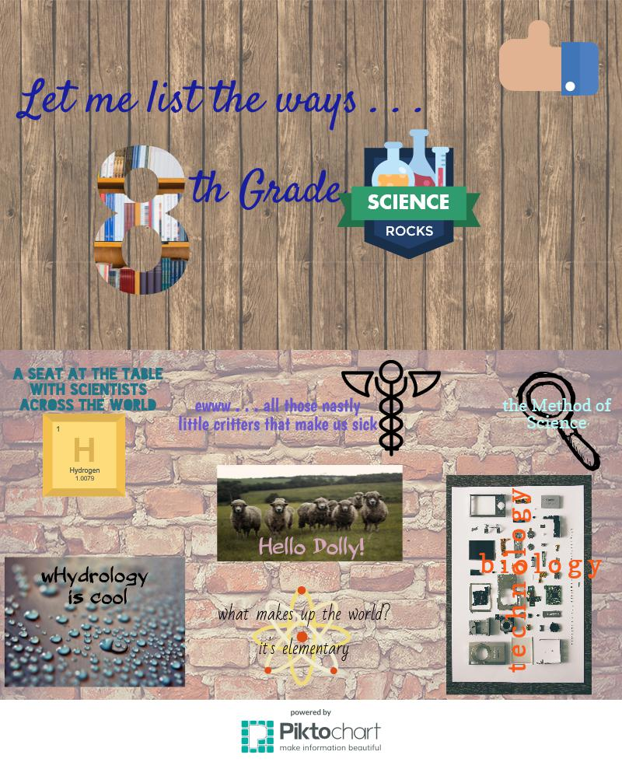
- Click the “Start for Free” button, then the “Sign Up with Google” button. Use your WCPSS email address. Do NOT make a new account.
- On the far left, choose the Infographic button. Then choose the first one – blank template.
- Click through the Tour in the bottom left corner.
- The menus are on the left hand side. This is how you add graphics, text boxes, pictures, change backgrounds, etc. You need to spend a few minutes playing around with this. It is very similar to programs like Publisher or Power Point.
- The “pages” are called “blocks.” You need a title block and two additional blocks.
- The file name is in the top black bar. Right now, it probably says “Untitled Infographic.” Click there to change the name to your last name and your partner’s last name. The save button is teal on the right side of that same black bar. It will save for you periodically.
- At the end of the week, when you are completely finished with everything, click on the “File” dropdown in the black bar. Choose “Download as Image.” You will only change one thing on this page – change file format to “JPEG.” Click “Download as JPEG.”
- Sign into your Google drive. At the top where it says “My Drive,” click the dropdown. Choose “Upload files” and find your JPEG file. Once the JPEG is in your Drive, right click on it and choose “Share.” Type in “dbelles” and click “Share.”
- You will NOT print anything for this project.

Piktochart Minimum Requirements
- Infographics are a way to share information in a less traditional way than a report or poster. Your infographic should be visually appealing. This is accomplished by changing font styles, colors, and sizes and creatively incorporating graphics with this text. Use of paragraphs should be limited. Make every word count.
- The “pages” are called “blocks.” You need a title block and two additional blocks.
- Your blocks need backgrounds.
- You will pair appropriate three graphics/photos/charts/maps with corresponding textboxes. No graphic should be alone; no textbox should be alone. A minimum of 9 pairs of these graphics and textboxes are expected.
1. You must have one graphic and textbox that compares/contrasts renewable vs
nonrenewable resources.

2 – 7. You must have one graphic and textbox for EACH of the following renewable
resources:

2. biomass
3. geothermal
4. hydropower
5. solar
6. wind
7. hydrogen

8. You must have one graphic and textbox for that discusses climate change.
9. You must have one graphic and textbox for ONE nonrenewable resource of your
choosing (choose from coal, natural gas, petroleum, or propane).

*Only ONE grading rubric is required if you worked with a partner. Put BOTH of your names on this paper.*
What do you think you (and your partner) deserve for this assignment? Why? If you worked with a partner, go into detail about what each of you contributed to the assignment.
________________________________________________________________________________________________________________________________________________________________________________________________________________________________________________________________________________________________________________________________________________________________________________________________________________________________________________________________________________________________________________________________________________________________________________________________________________________________________________________________________________________________________________________________________________________________________________________________________________________________________________________________________________
Points | 30 | 25 | 20 | 15
Graphics | All graphics are paired with textboxes and are related to the theme or purpose of the infographic. | All graphics are paired with textboxes and most are related to the theme or purpose of the infographic. | Some graphics or textboxes are by themselves or are related to the theme or purpose of the infographic. | The student did not follow instructions. The graphics and textboxes do not relate to the theme or purpose of the infographic.
Points | 45 | 35 | 25 | 15
Content | A title block and two additional blocks have been included. There is 1 graphic/textbox for renewable vs nonrenewable, 6 graphics/textboxes for renewable energy sources, and 1 graphic/textbox for a nonrenewable energy source. The content of the infographic is accurate and clear. The infographic is creative and there is attention to detail. It is obvious a lot of effort went into the assignment. Work meets or exceeds all expectations for 8th grade thinking and rigor. | A title block and two additional blocks have been included. Although 9 graphics/textboxes were expected, only 7 or 8 were included. Most of the content is accurate and clear. The infographic is fairly creative and it is obvious the student tried to do a good job. Most expectations for 8th grade thinking and rigor are met. | A title block and two additional blocks have not been included. Although 9 graphics/textboxes were expected, only 5 or 6 were included. The infographic shows some creativity. There are several content errors and not all information is accurate. The student did not show much effort. Some expectations for 8th grade thinking and rigor are met. | A title block and two additional blocks have not been included. Although 9 graphics/textboxes were expected, less than 5 were included. The infographic lacks creativity and a lot of the information is missing or incorrect. The student did not put forth any effort on this assignment. Few expectations for 8th grade thinking and rigor are met.
Points | 15 | 10 | 5 | 2
Grammar & Mechanics | Proper grammar, spelling, and mechanics are used throughout the infographic. | Proper grammar, spelling, and mechanics are mostly used on the infographic, but there are a couple errors. | There are several mistakes in grammar, spelling, and mechanics on the infographic. | It appears that the student did not edit the infographic, because there are so many errors in grammar, spelling, and mechanics.
Points | 10 | 7 | 5 | 2
Reflection | Reflection is detailed and provides support for grade deserved. | Reflection makes an effort but lacks details and support for grade deserved. | Reflection is unconvincing. | Reflection is missing or very little effort was put into completing it.

