 | Problem 1 | Problem 2 | Gridded Response
Monday | The area of a square is 30 inches. Would the side length of this square be rational or irrational? | Alice received $150 for his birthday. She then saved $20 per week until she had a total of $390 to buy a new cell phone. Write and solve an equation to show how many weeks it took her to save the money. | Problem 2  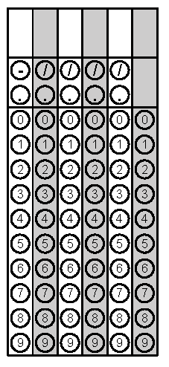
Tuesday | A utility pole has a 50ft. cable stretched from the top to an anchor point on the ground 30 ft. from the base of the pole. How tall is utility pole? | Use the graph to find the solution of the system of equations.  y = 2x – 2  y = $-\frac{5}{2}x$ + 7  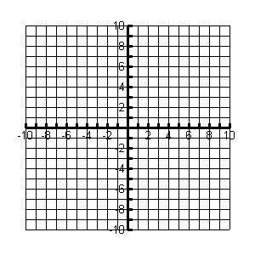 | Problem 1
Wednesday | What type of correlation would you expect between the cost of a gym membership and the number of new memberships sold? | Samuel bought three plastic cones with a diameter of 8 cm and a height of 5.5 cm. Find the volume of the three cones to the nearest cubic centimeter. | Problem 2
Thursday | The growing rate of a sunflower at Store A can be described as $y=\frac{5}{2}x+10.$  The growing rate of a sunflower at Store B is given in the table.  Days Height(in)  0 10  1 13  2 16  3 19  Which slower would you buy if you want to buy the fastest growing sunflower? | The points (–4,–2) and (–4, 5) are adjacent vertices of a rectangle. Two of the sides of the rectangle have a length of 5 units. What is the length of a diagonal of the rectangle? Round to the nearest tenth. | Problem 2
Friday | Find the sum of x and y.  y = 3x - 2  2y = 4x + 10 | Approximate $\sqrt{20}$ to the nearest tenth. | Problem 1

