Notes: 1930s/Great Depression Name: ____________
1930’s VOCABULARY – Use the PPT: 1930s PowerPoint and web sources to define:

1. Bull Market -

2. Buying on Margin -

3. Speculation -

4. Stock Market Crash – When? ____________ What happened?

5. Bear Market -

6. Great Depression -

7. Hoovervilles -

8. Dust Bowl –

9. Okies –

10. Fireside chats –

11. New Deal -

1930’s and the Great Depression
POWERPOINT PRESENTATION

12. For most of the 1920’s there was a __________ market.
13. A _________ is when the stock market was doing well and stock prices were __________.
14. TWO Problems with the stock market:
- Buying stocks on ___________- buying stocks using _______, not cash
- Speculation- buying stocks in the hope of making a ___________
15. From 1929-1932 there was a _____________- A _______ market is when the stock market was NOT doing well and stock prices _________
Stock Market Crash

16. Everyone tried to ________ their stocks and the stocks became _________________.
17. When the stock market crashed, people went to the banks to get their money, but it was ________! Watch Brainpop on Causes of the Great Depression and answer questions:
https://www.brainpop.com/socialstudies/ushistory/greatdepressioncauses/
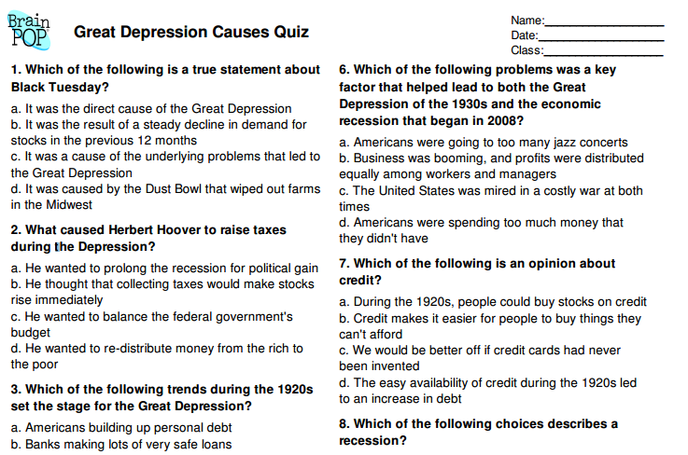
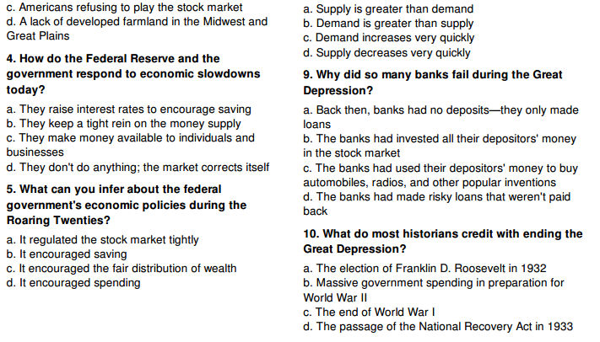
What were the causes of the Great Depression? (Use PPT to fill in)

Installment Buying and buying ______ on ___________

T
H
E

G
R
E
A
T

D
E
P
R
E
S
S
I
O
N

Banks _____ money without any to back it up, so when people went to get their __________ out of the bank it was _____

The overproduction of goods and ______. Factories and ________ were producing too much causing prices to go down

Cycle of __________- businesses can’t get loans from _______, so businesses cut wages, hours, and laid off workers don’t have money to buy goods, so businesses went ____________

United States made large _____ to ______, but we had to stop giving loans, which caused Europe’s banks to _____. The same cycle occurred overseas causing a __________________

The Dust Bowl

How were the black blizzards of the Dust Bowl formed? Read the paragraph on PPT and fill in:

18. Severe drought hit the _________ from 1931-1939. The black blizzards formed from the _______ and 50 mph winds. They destroyed over _______________ acres of land. It ended when ______ finally fell consistently and temperatures remained steady. During the Dust Bowl, temperatures changed ____ degrees in a matter of hours. In addition there were record highs of 120 degrees and no rain for _________. The Dust Bowl forced hundreds of _________ and their families to move ______ to _______________ to start a new life

Who were Okies?

19. A family from Oklahoma packed up all their belongings and headed for ___________ where they hoped to find better soil and start a new life. These _________ families were nicknamed ____________
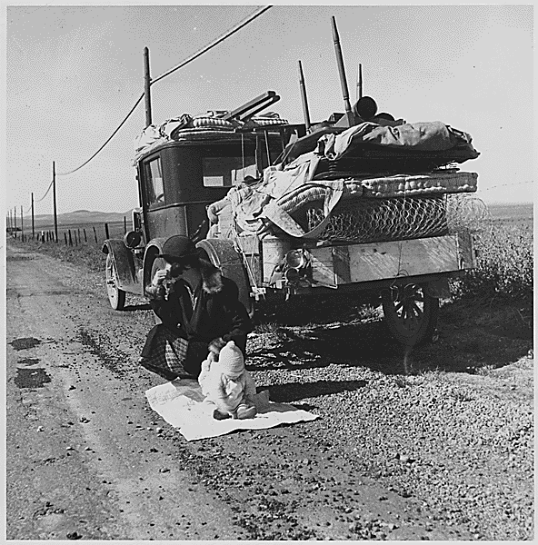
President Herbert Hoover
31st President
1928-1932

20. What did President Hoover believe about the economy?

- Herbert Hoover believed in _____________ government. Laissez-Faire means __________________________________. He started some programs to help the United States get out of the _________________ but they did not apply to the masses of people who were ______________
- Most people did not believe Hoover was doing enough, so the shacks that the ________ people lived in were called ____________ and the __________________ that people covered up with were called Hoover blankets

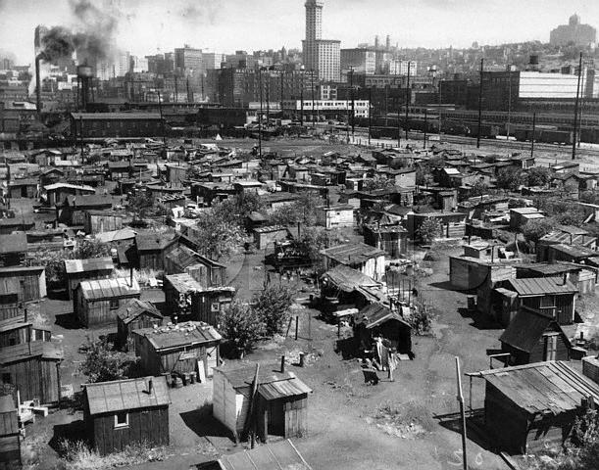

21. Read the article at http://www.livinghistoryfarm.org/farminginthe30s/water_02.html
and answer the questions:
- Who was eventually effected by the Dust Bowl? ______________
- Describe the impact of the dust storm on Black Sunday: ____________________________________________________________________________________________________________________________________
- What did the Great Plains need to end the Dust Bowl? _______

22. Watch Brainpop: The Great Depression
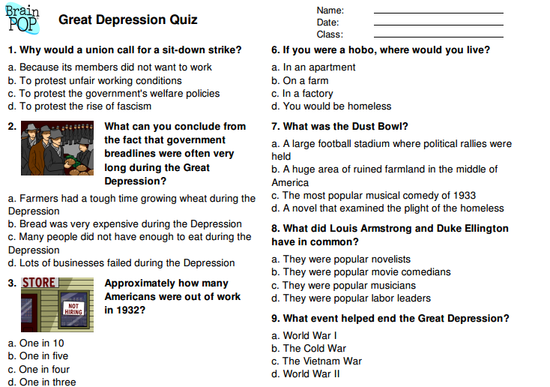
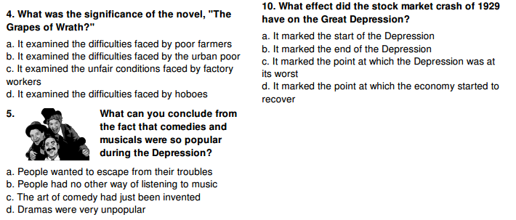

23. What was the bonus army? How did President Hoover respond?
- World War I __________ nicknamed the “__________” asking for President Hoover to give them their army bonuses early. Veterans of this war were promised a bonus not to be given until 1945. Because of the Great Depression, over 60,000 veterans marched on _________________ asking for it to be given early. President Hoover _________ their request, but paid for their railway tickets back home instead.

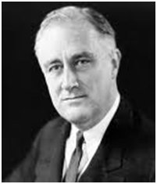
Franklin Delano Roosevelt
32nd President
1932-1945

24. Why did FDR win a landslide victory?

People were fed up with the lack of results from _________ programs
and Franklin Delano Roosevelt (FDR) won a landslide victory in _______.
People were happy to see Roosevelt’s new programs started in his first
________ in office. However not everyone was happy. Many __________
criticized FDR’s approach to taking over ___________. This seemed too close to communism for some people. ___________ didn’t pass several of FDR’s programs, but hundreds of others were still passed.
25. Watch Brainpop on FDR and answer questions:
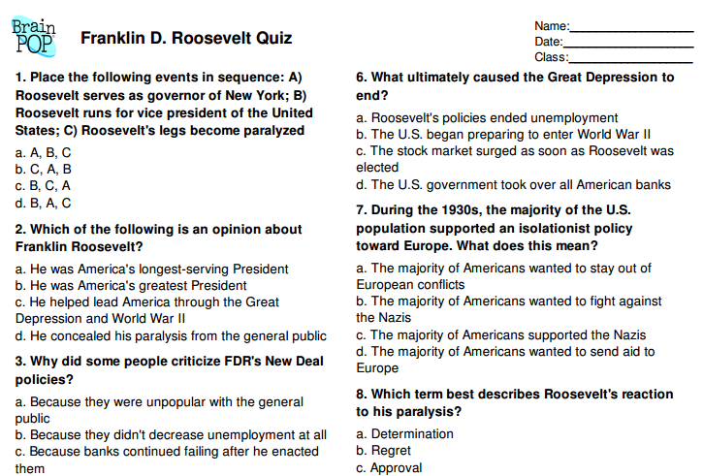
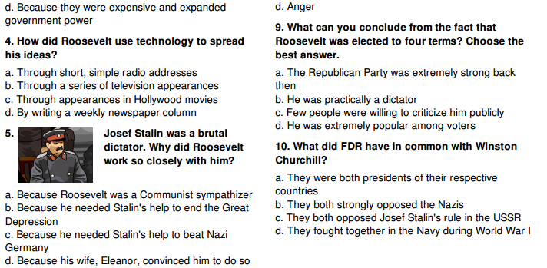

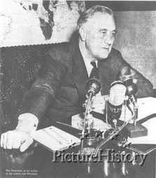
26. What were fireside chats?

Fireside Chats – President Roosevelt spoke to the American public over the ___________. “Tonight, (May 7, ________) I come to you for the second time to give you my report -- to tell you about what we are doing and what we ___________ to do.”

27. Here are some examples of what FDR told people to make them feel better about their situation:
- Congress is about to pass legislation that will help _________ and __________ pay their mortgage (money they owe on their homes)
- A grant of half a __________ dollars is to be given to care for those who need direct and immediate relief.
- Congress authorized the sale of ___beer__ in such states as desired. This has already resulted in _____job growth_____ and has provided much needed ___tax__ revenue.

28. What was the New Deal? ______________________________________________________________________

Some of the New Deal Programs

Name of New Deal program | Describe the program
SSA – Social Security Act  *Still exists today* | Provided __________ benefits, ____ ______ and ________ and aid to the elderly and to the disabled
TVA – Tennessee Valley Authority | Federal government built a series of _______ to prevent flooding, brought _____ supply and ___________ to rural areas- provided jobs for people who helped with construction
CCC – Civilian Conservation  Corporation | Sent 250,000 young men to work camps to perform reforestation and __________ tasks. Removed surplus of workers from _______, provided healthy conditions for boys, and provided ___________ for families
AAA – Agricultural Adjustment Agency | Protected farmers from price _____ by reducing production, and starting ____educational__ programs to teach methods of preventing ___soil___ erosion
FDIC – Federal Deposit Insurance Corporation  *Still exists today* | Created federally insured bank ________ ($______ per investor at first) to prevent bank _________. Now protects up to $__________ per investor.
PWA – Public Works Administration  Define Public Works: Projects built by the government for public use like parks, schools, highways, roads, government buildings, | States received $3.3 billion appropriation from _________ for public works projects.  Provided _________ to needy areas through public projects

SEC – Securities and Exchange Commission  *Still exists today* | Regulated the _______ market and restricted ________ buying
FERA – Federal Emergency Relief Act | Distributed millions of dollars of direct aid to unemployed workers, including food, _________, shelter, and ________ training.  For example, teaching women to sew and providing sewing machines to make clothes for their families. Also, creating a community garden projects where people work planting food and take home what they have produced

Watch Brainpop: New Deal and answer questions:
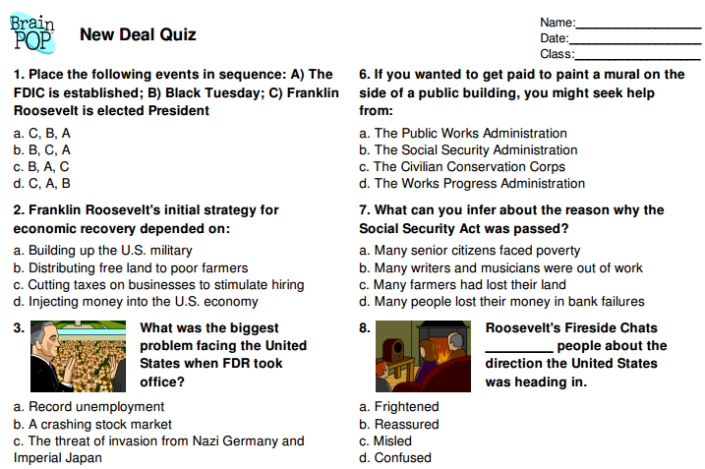
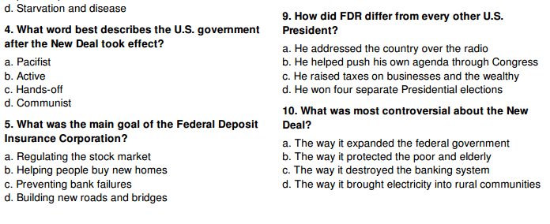
29. FDR’s New Deal programs helped ________ some problems by giving people jobs, food, and shelter. It __________ some problems, such as the banking system (FDIC) and pay for the elderly and handicapped (SSA). However it did not completely __________ America’s economy from the Great Depression before the start of World War II. Recovery from a depression takes a long time and the start of ________ will make this happen faster than the New Deal could have.

30. What programs still exist today?
The _________, _________, and _______ were so important that they still exist today.
31. Explain some of the criticisms of the New Deal:
- Gave the ________ government too much power
- Cost too much _____________
32. Was there good reason for these criticisms? Why or why not?

33. What pulled the United States out of the Great Depression so quickly?

Producing goods (such as weapons, _______, tanks, ________, and other supplies for the ______________) for WWII is what pulled the US out of the Great Depression. We had to mobilize all of our factories to help in the war effort producing new jobs all over the country.

Heroes and Entertainment

of the 1930’s

34. Popular movies of the 1930’s:
Gone with the _______- about the Civil War
Snow White and the 7 _______- Disney classic
Wizard of Oz- this is the story about Dorothy and her magical trip to OZ
_________- story of a giant ape that is captured from mysterious skull island then brought back to the mainland

35. Radio Programs:
War of the ________, created by Orson Wells
FDR’s _______ chats- done weekly from the White House to help inform the public of what the government was doing to fix the Great Depression

36. Legends and heroes of the 1930’s:
Jesse _____- Olympic star of the 1936 games, won FOUR gold medals in track and field events in Berlin, Germany
Joe _______- Baseball star on the New York Yankees, record
Amelia _______- famous female pilot, went missing on her solo flight around the world in 1937

37. New Board Games: ___________

38. SUM UP THE GREAT DEPRESSION

CAUSES OF THE GREAT DEPRESSION:

1.)

2.)

3.)

4.)

EFFECTS ON THE AMERICAN PEOPLE:
List at least 4

FDR CREATES THE _______ _______.
WHICH DOES WHAT?

PROGRAMS MEANT TO HELP PEOPLE: (LIST ALL IN NOTES)

THE U.S. FINALLY GETS OUT OF THE GREAT DEPRESSION, BUT COMPLETELY BECAUSE OF FDR’S
_________ ________, BUT
BECAUSE OF ________.

